Task2- Adaline Learning Algorithm Using MSE

Team - SC_H22

| Name | ID |
| --- | --- |
| نورا إكرامى على يوسف | 20191700703 |
| نورهان محمود أحمد السيد | 20191700718 |
| أيمن حسن توفيق | 20191700160 |

# Adelie and Gentoo

### bill_length_mm , bill_depth_mm

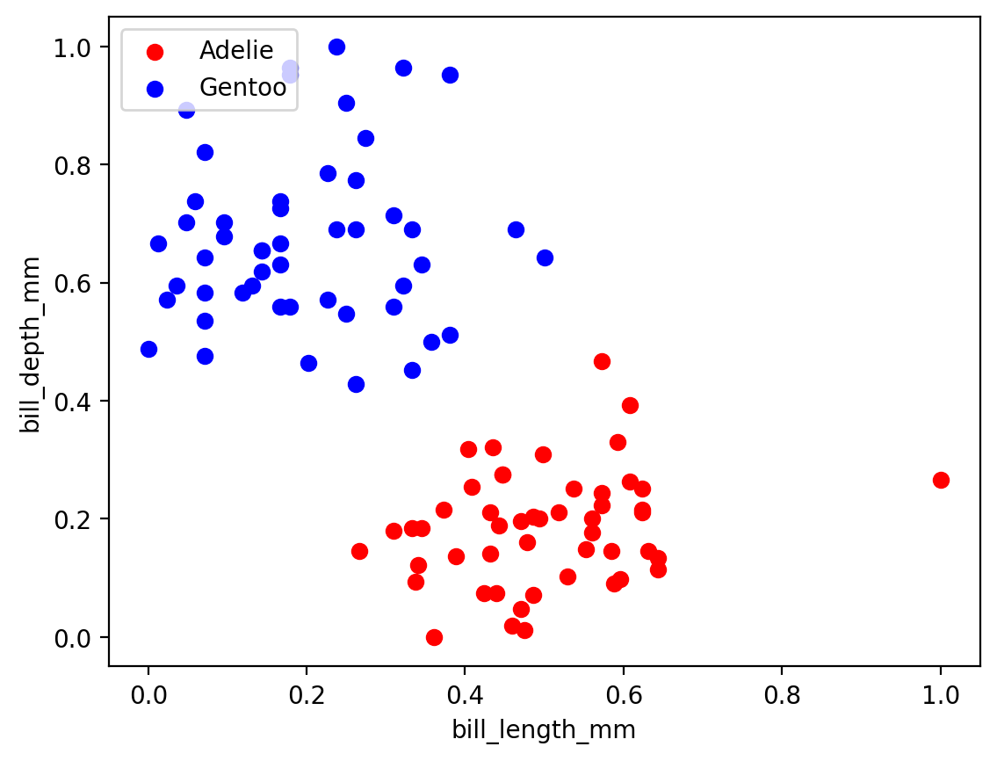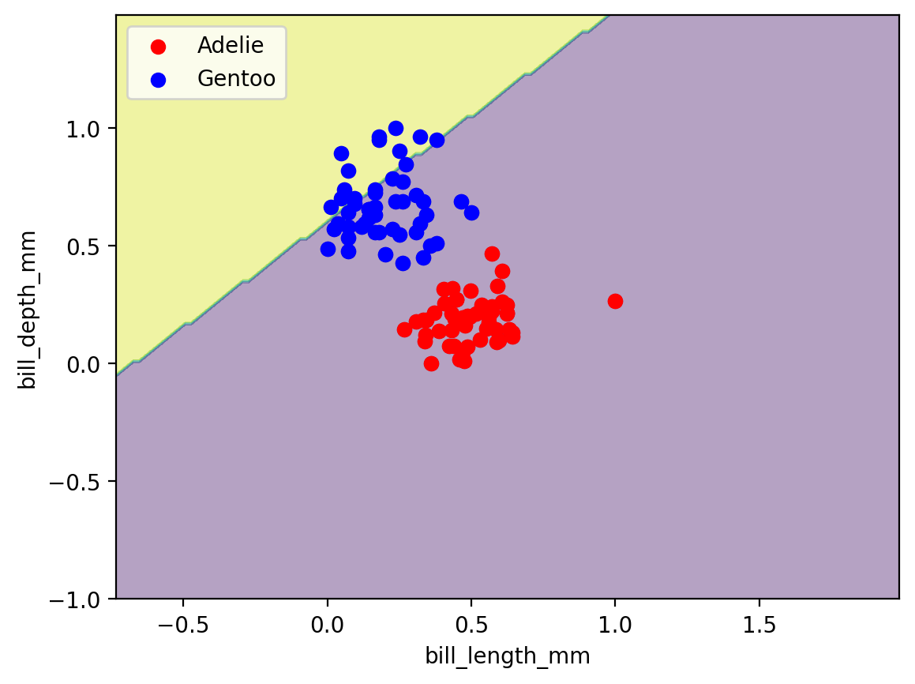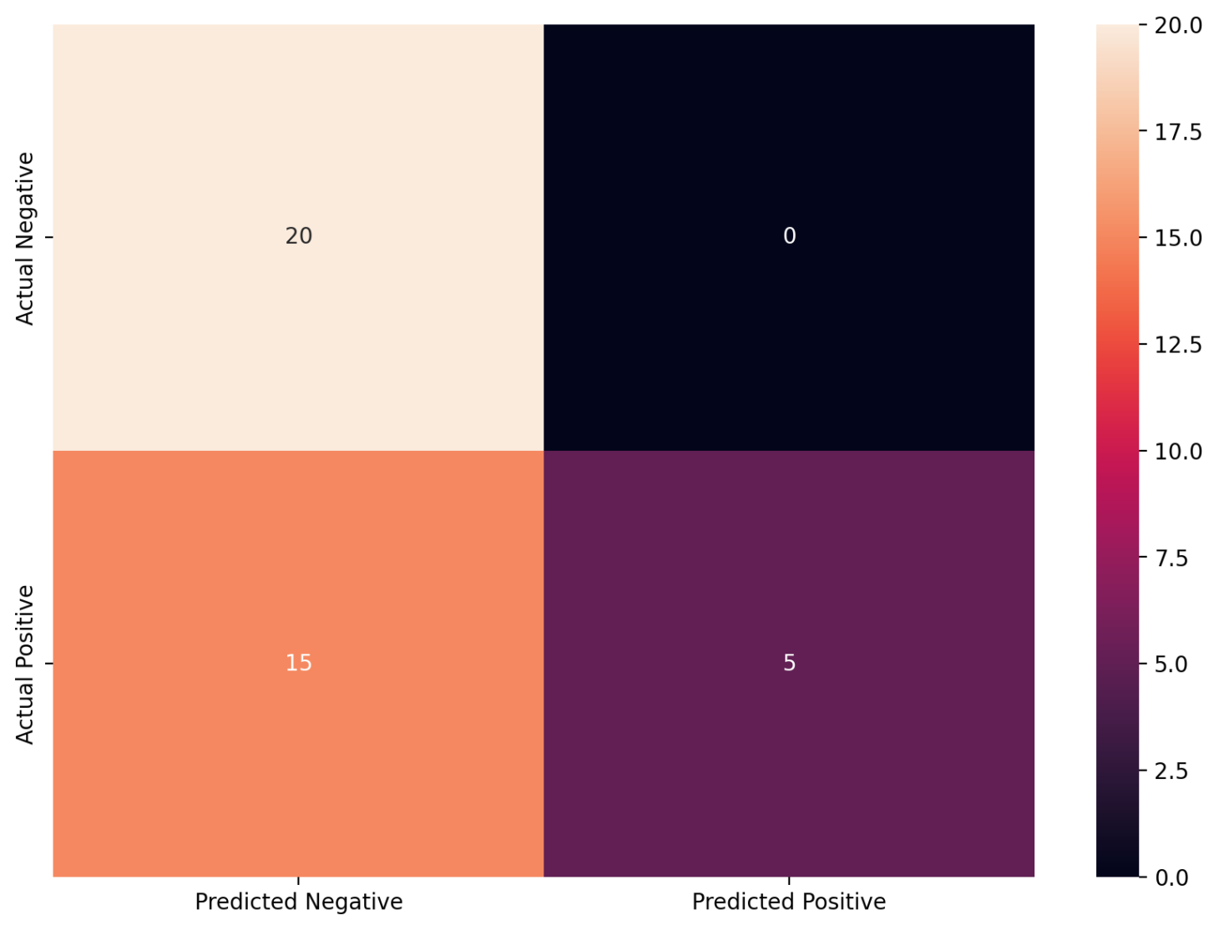

**Comment:**test accuracy = 0.625

### bill_length_mm, flipper_length_mm

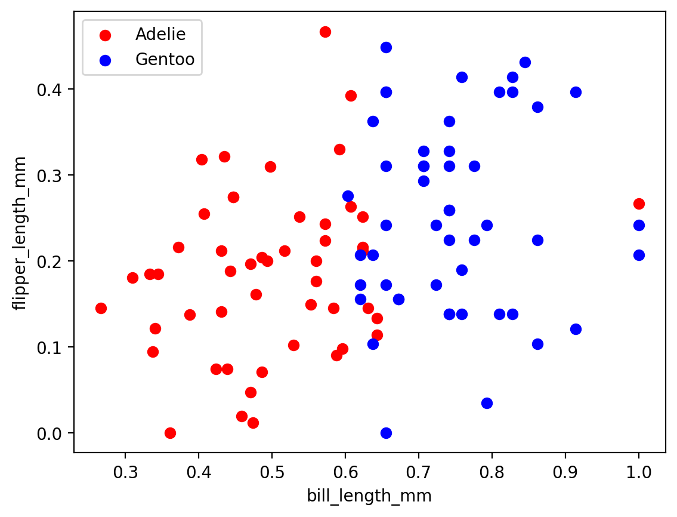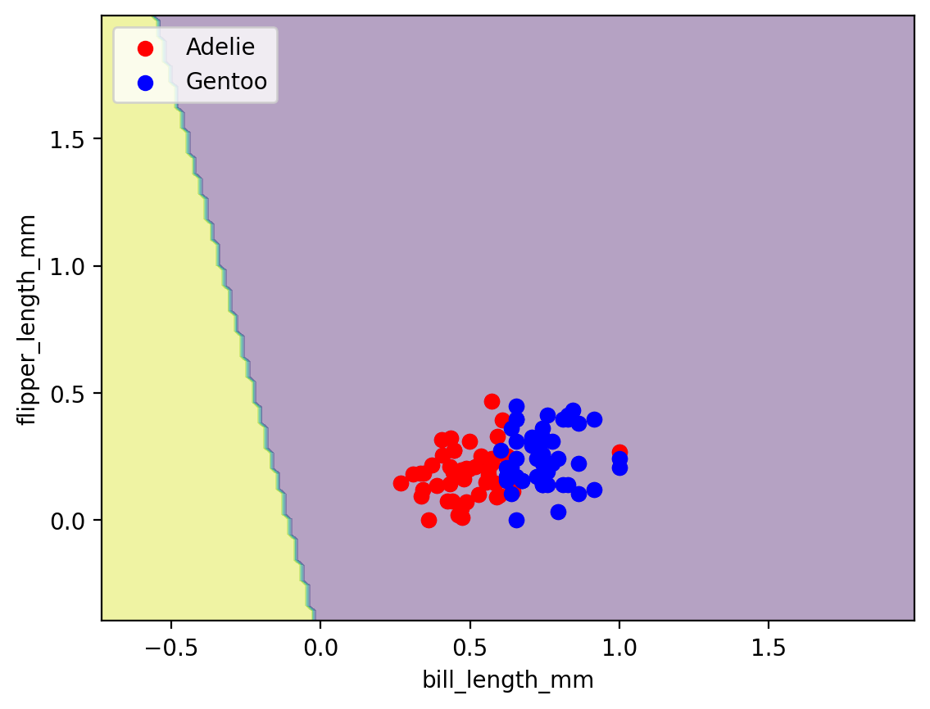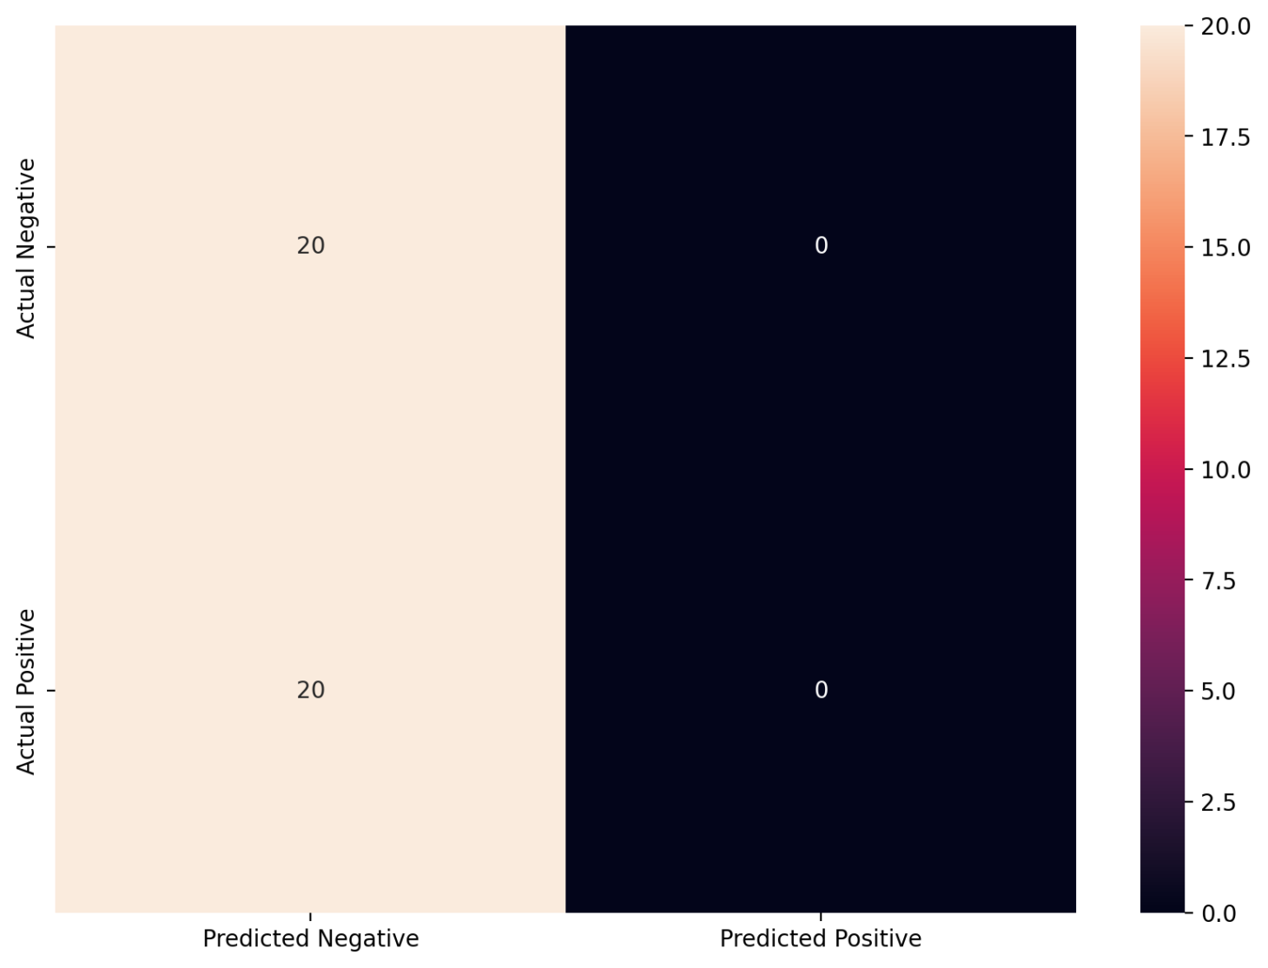

**Comment:** test accuracy = 0.5

### bill_length_mm , gender

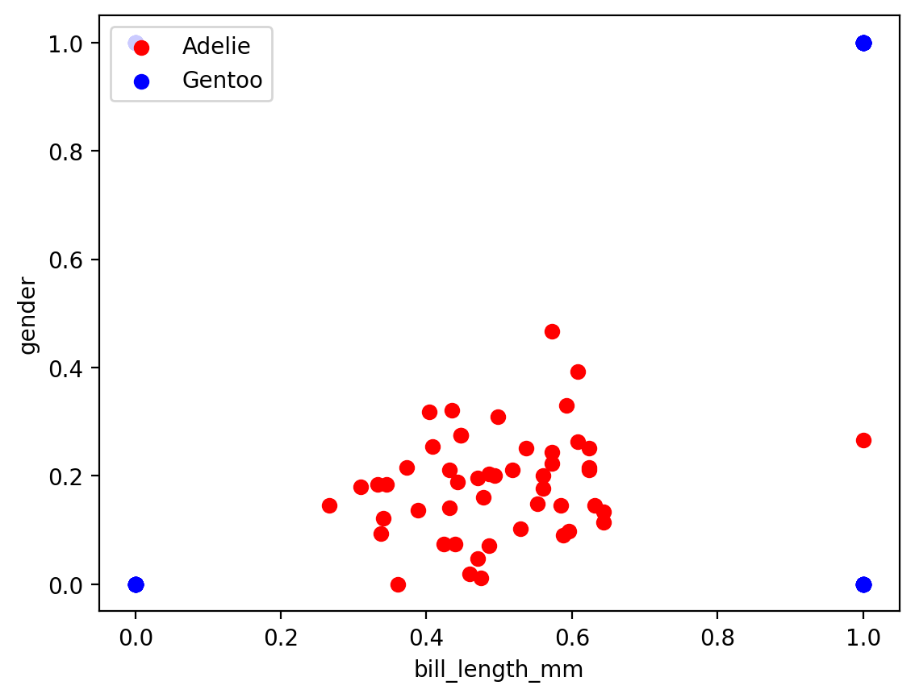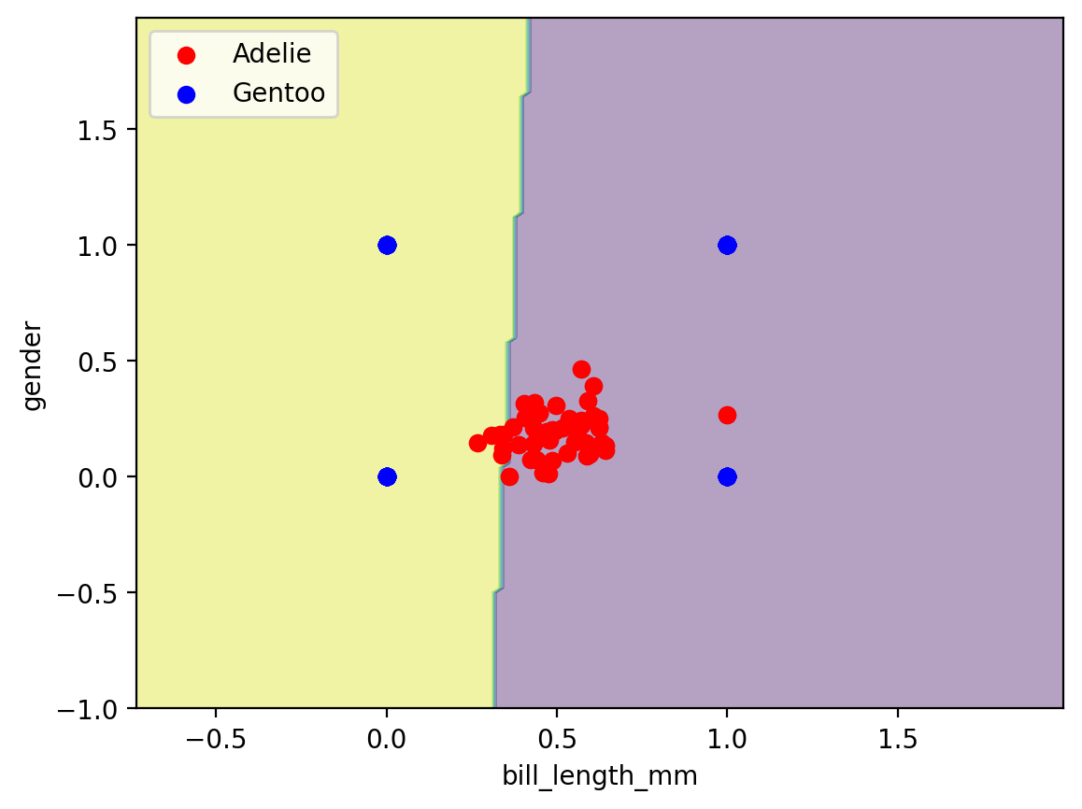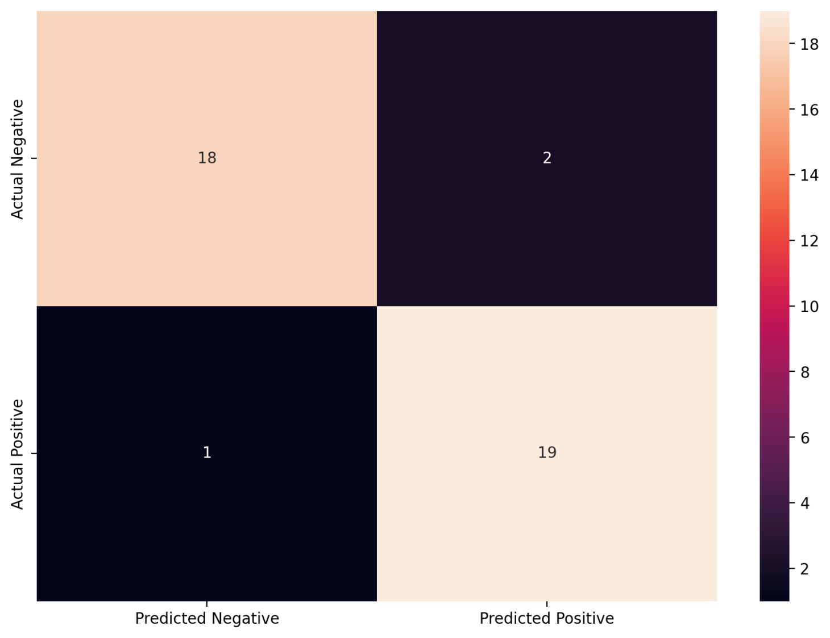

**Comment:** test accuracy = 0.925

### bill_length_mm , body_mass_g

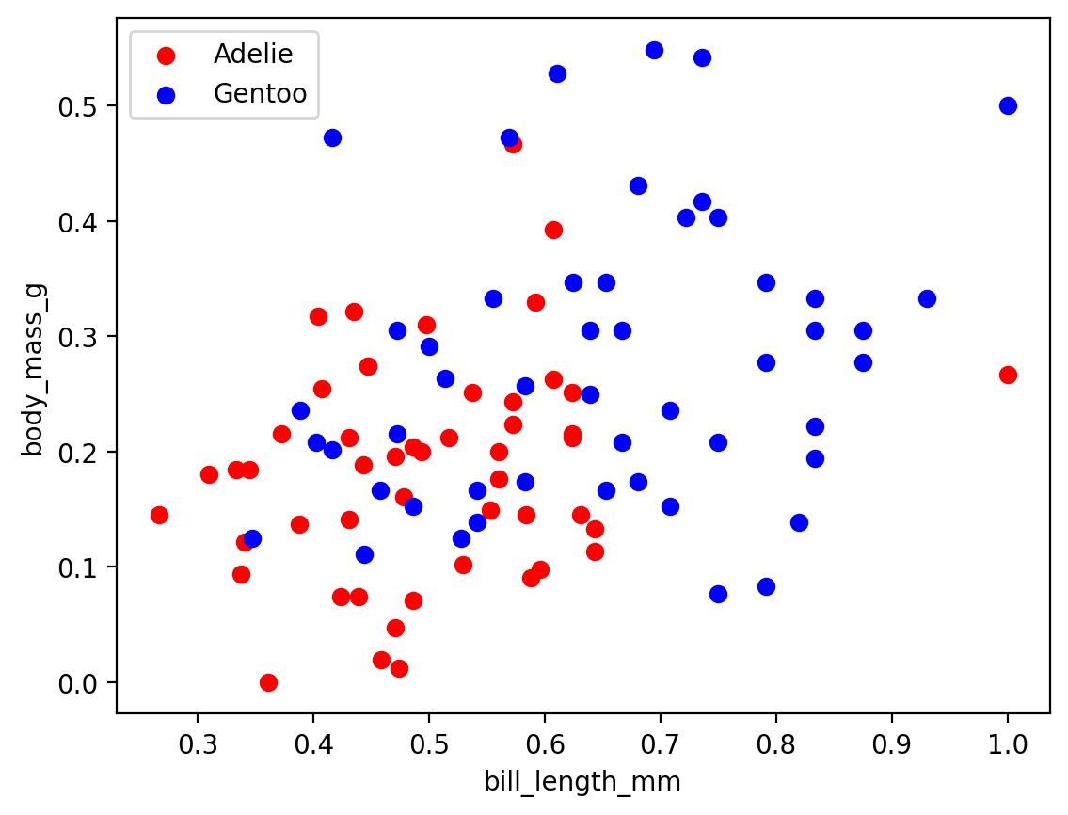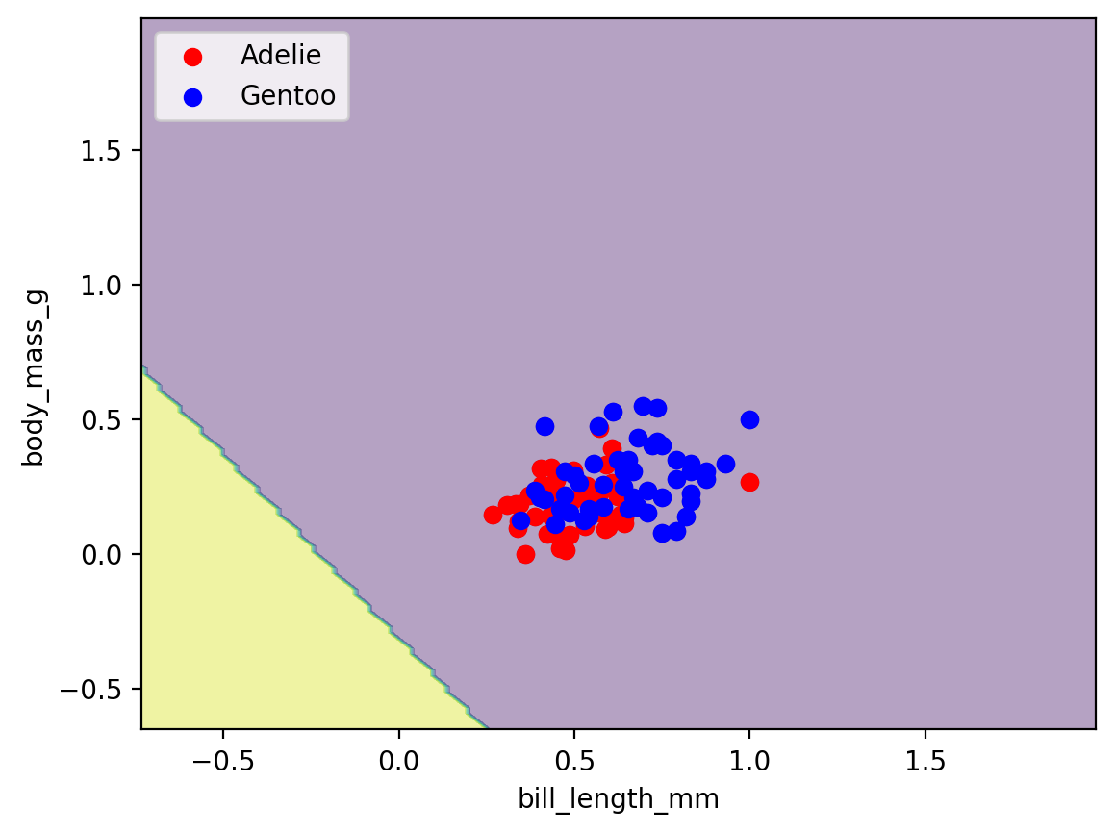

**Comment:** test accuracy =0.5

bill_depth_mm , flipper_length_mm

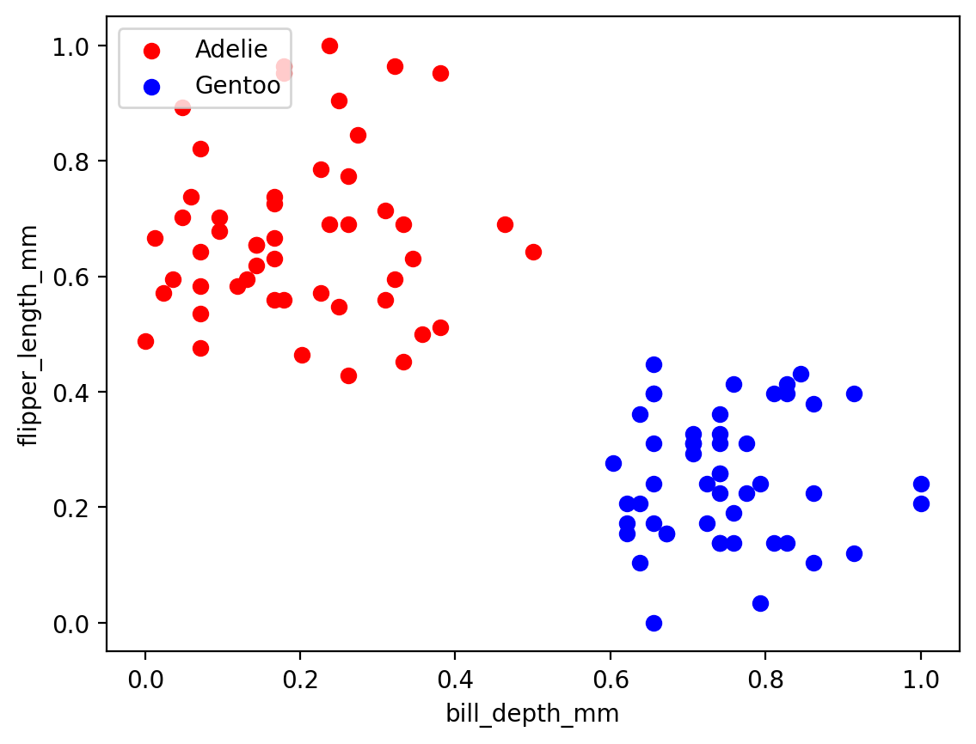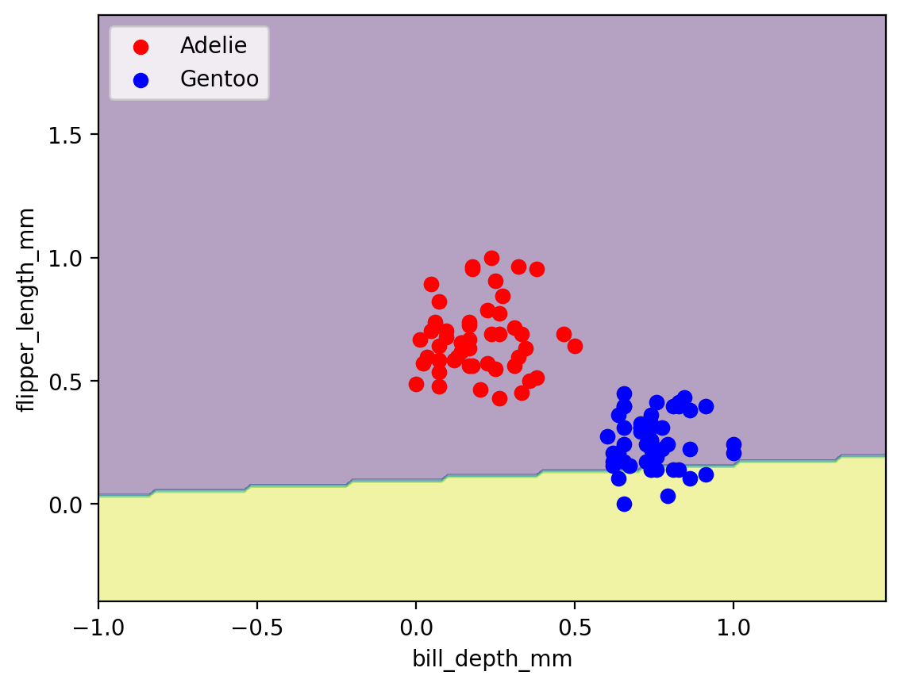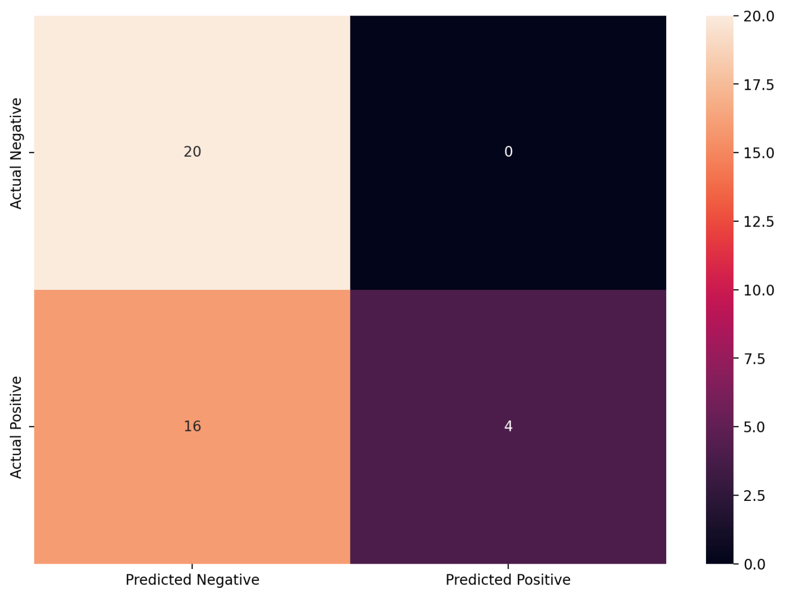

**Comment:** test accuracy = 0.6

bill_depth_mm , gender

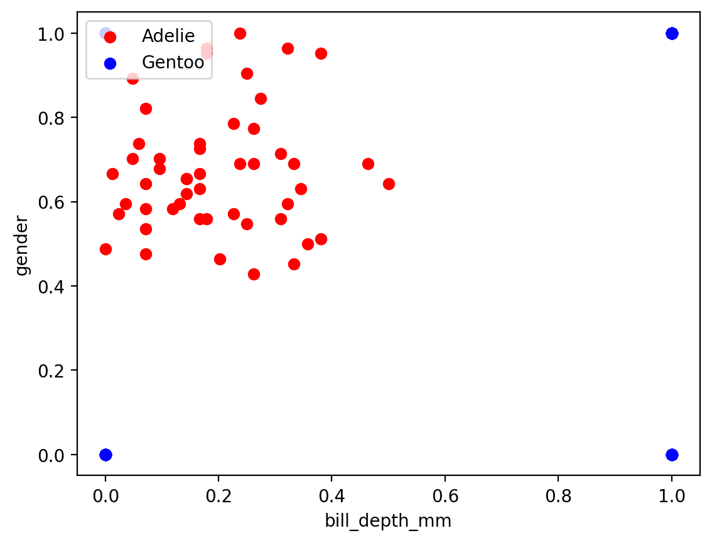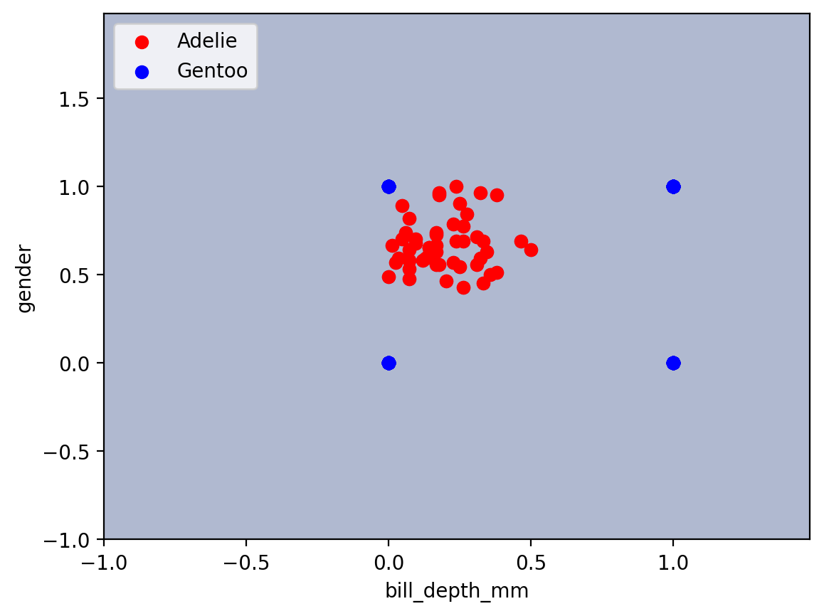

**Comment:** test accuracy = 0.5

### bill_depth_mm , body_mass_g

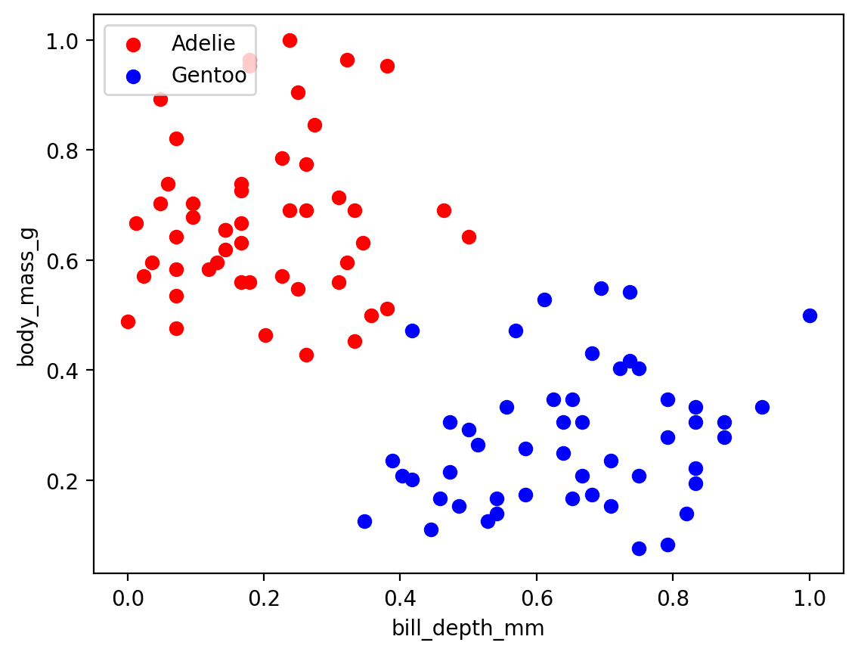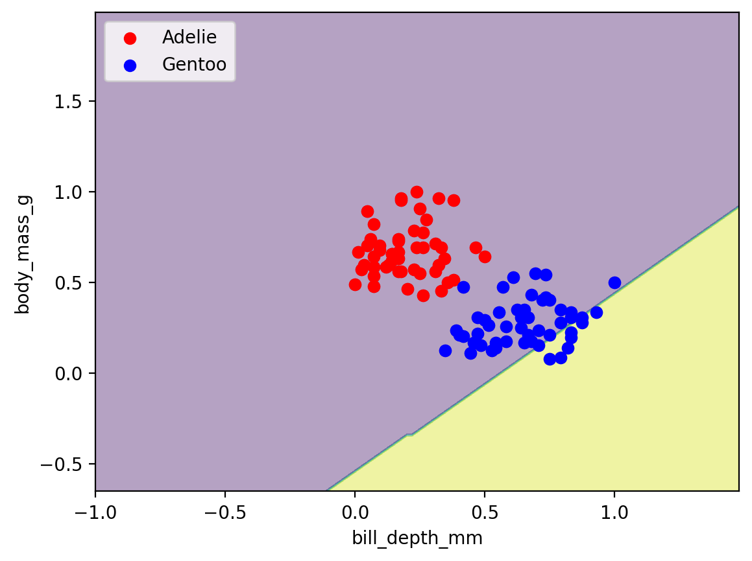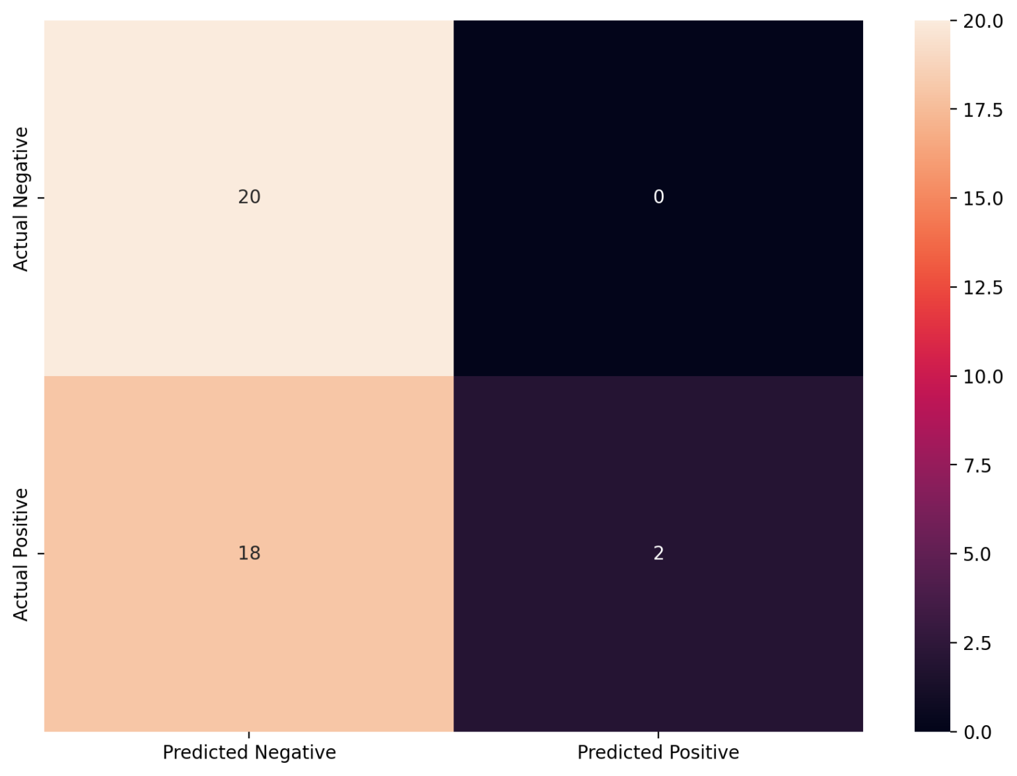

**Comment :** test accuracy = 0.55

### flipper_length_mm , gender

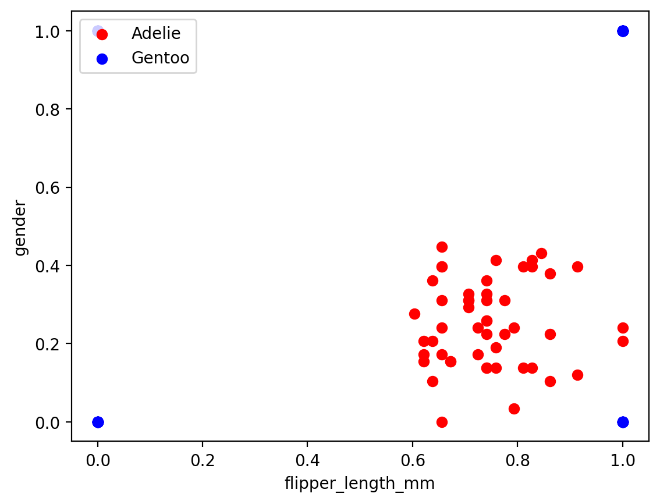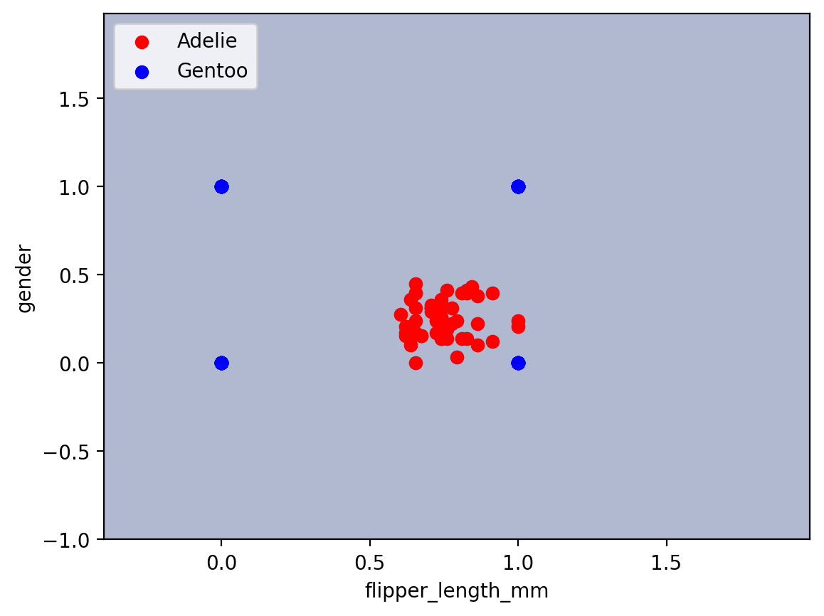



**Comment :** test accuracy = 0.5

flipper_length_mm , body_mass_g

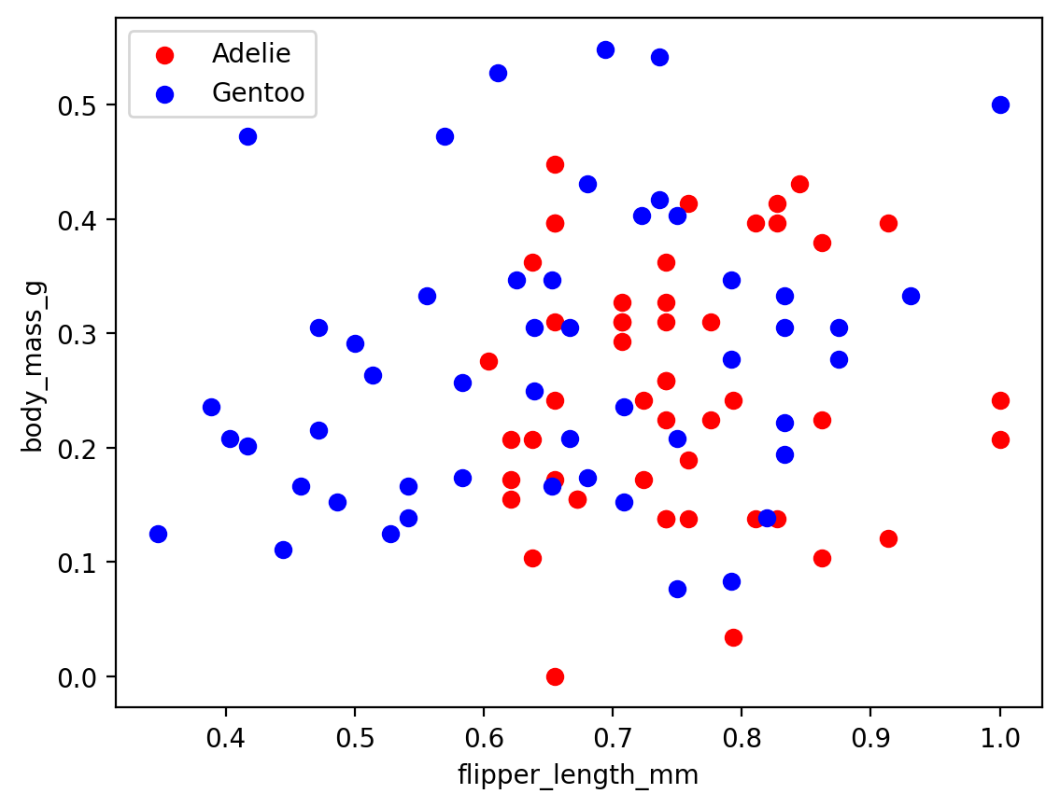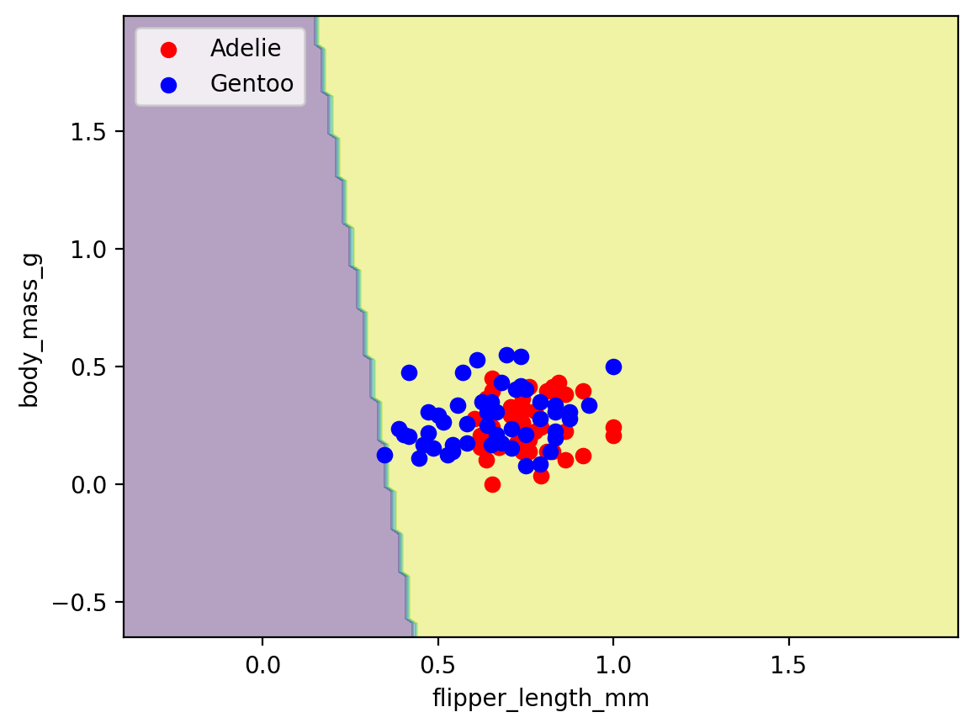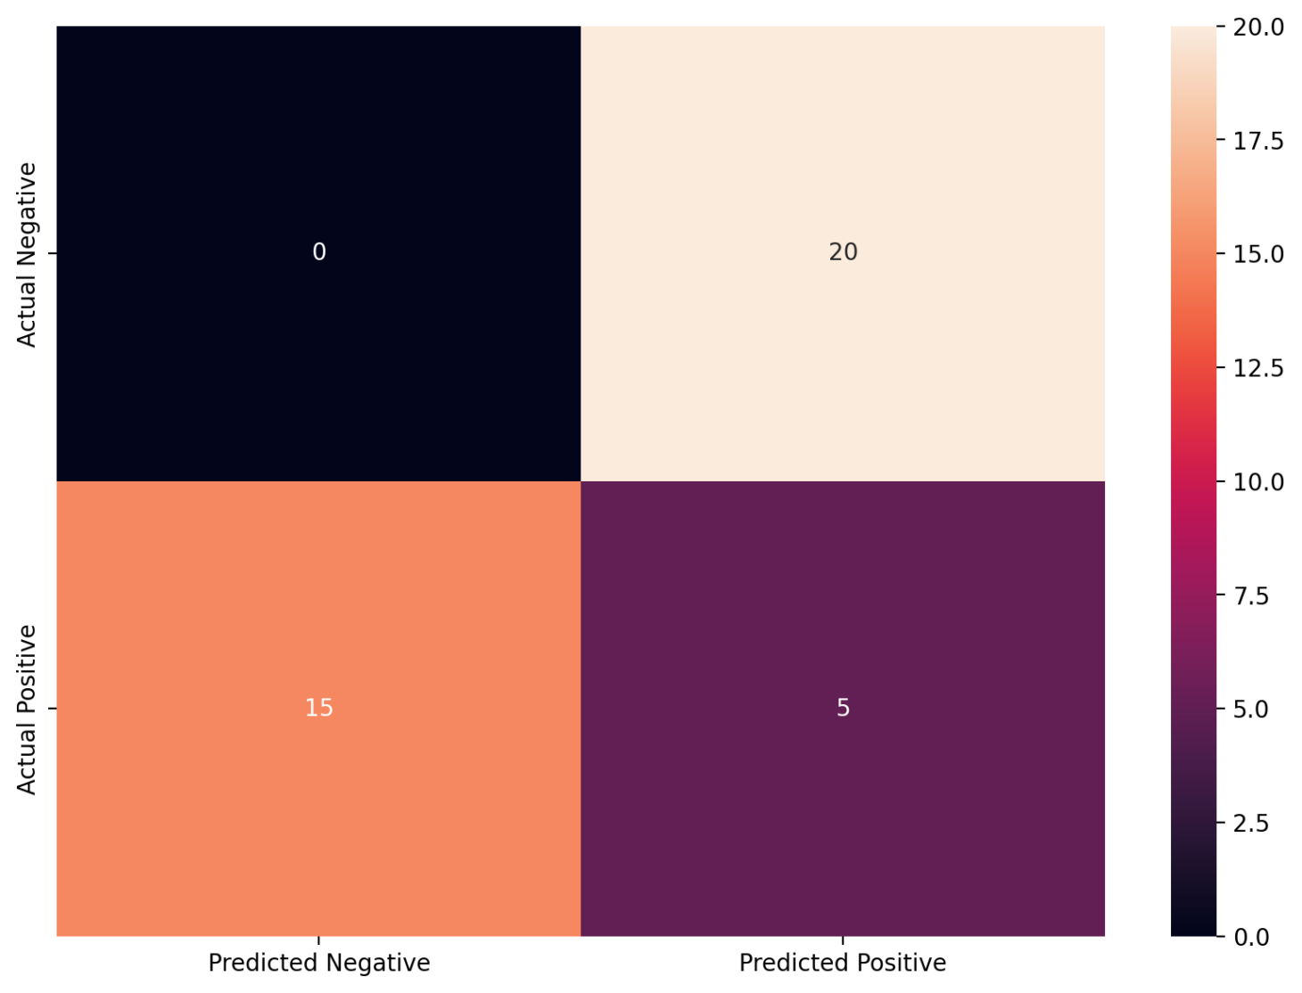

**Comment:** test accuracy = 0.125

### gender , body_mass_g

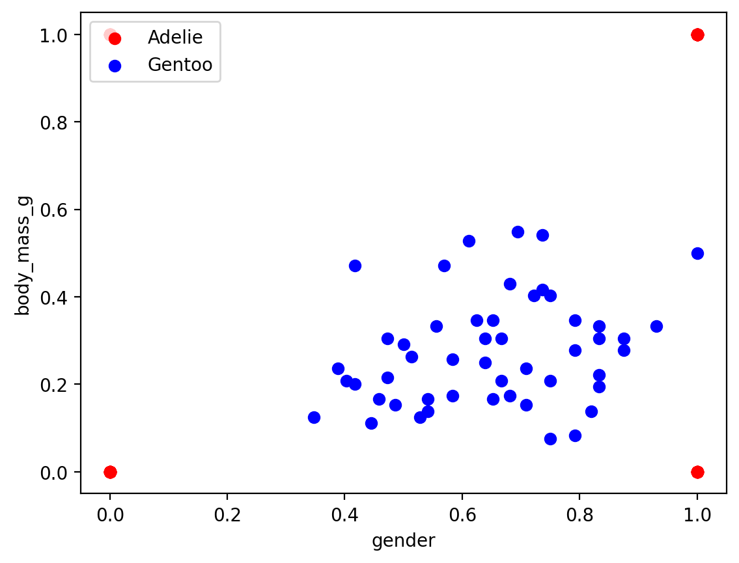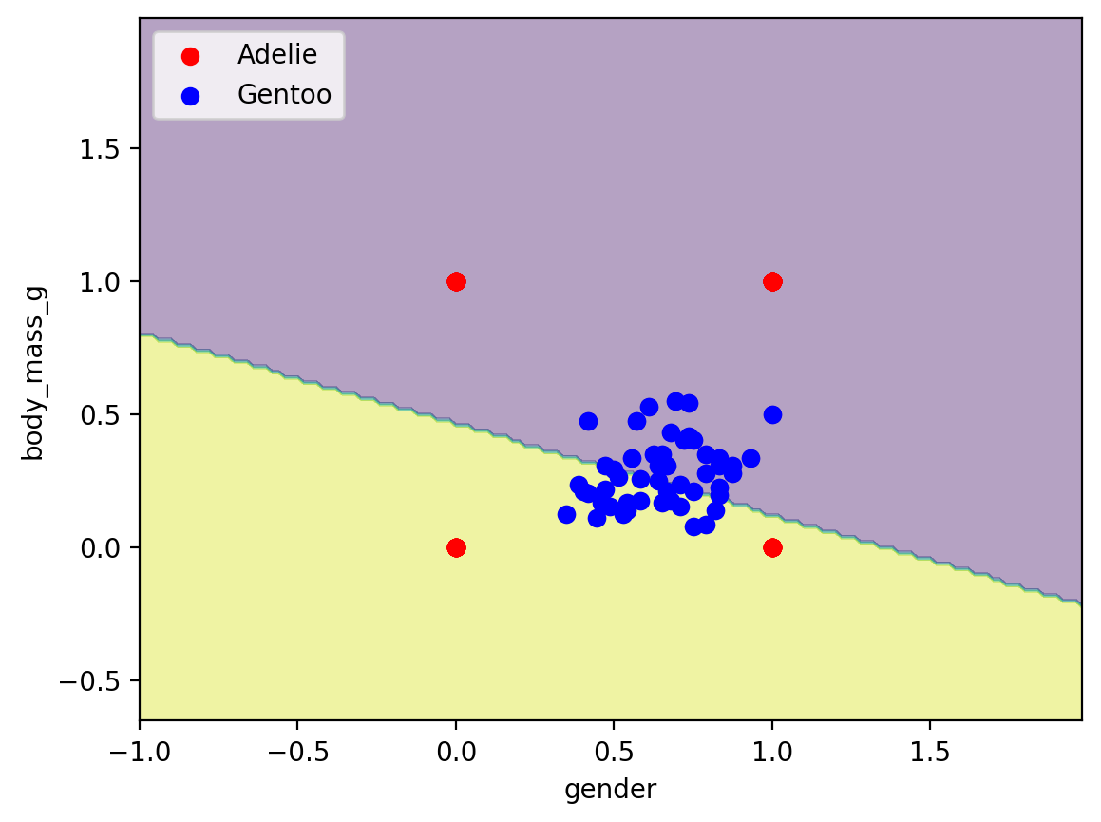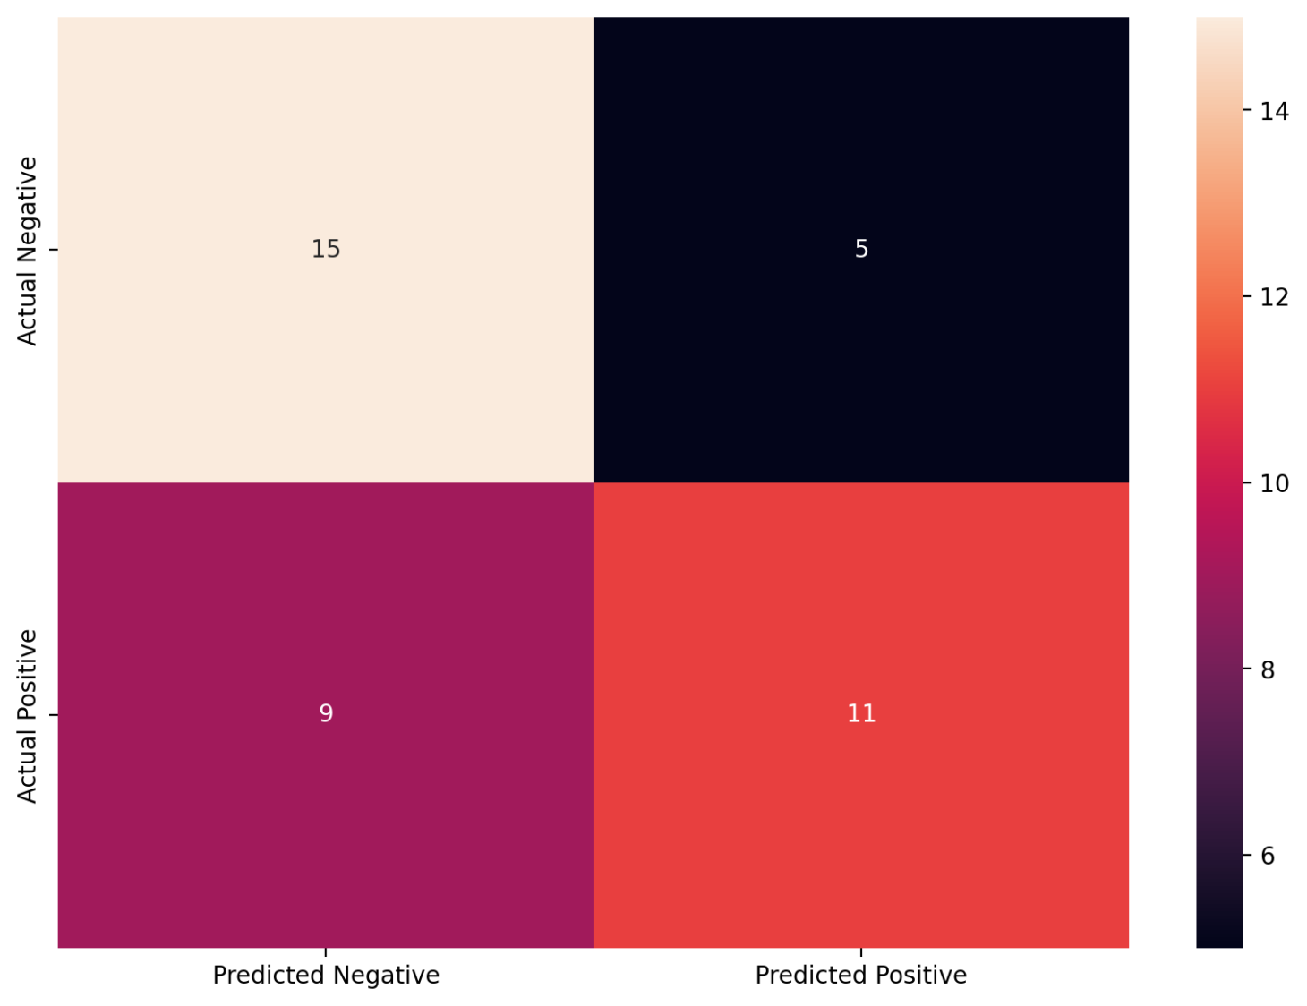

**Comment:** test accuracy = 0.65

# Adelie and Chinstrap

### bill_length_mm , bill_depth_mm

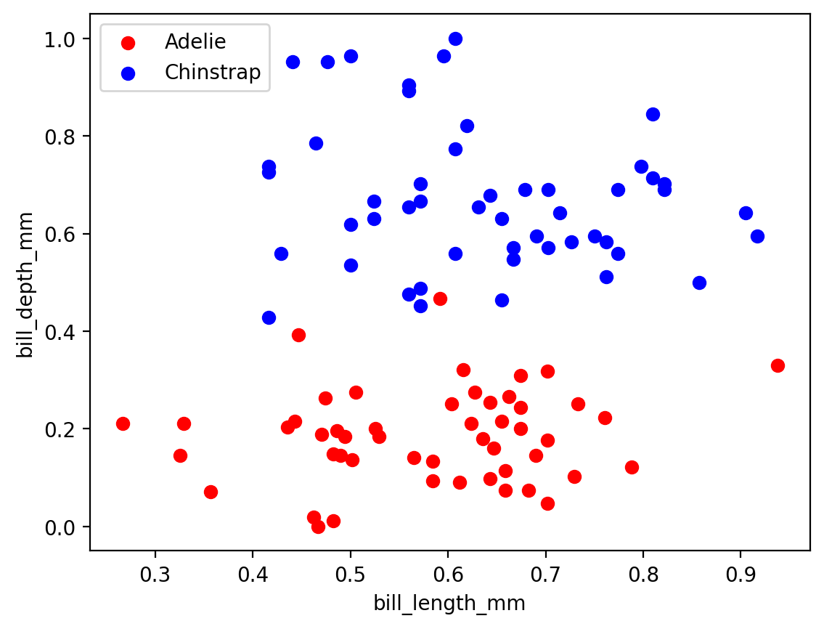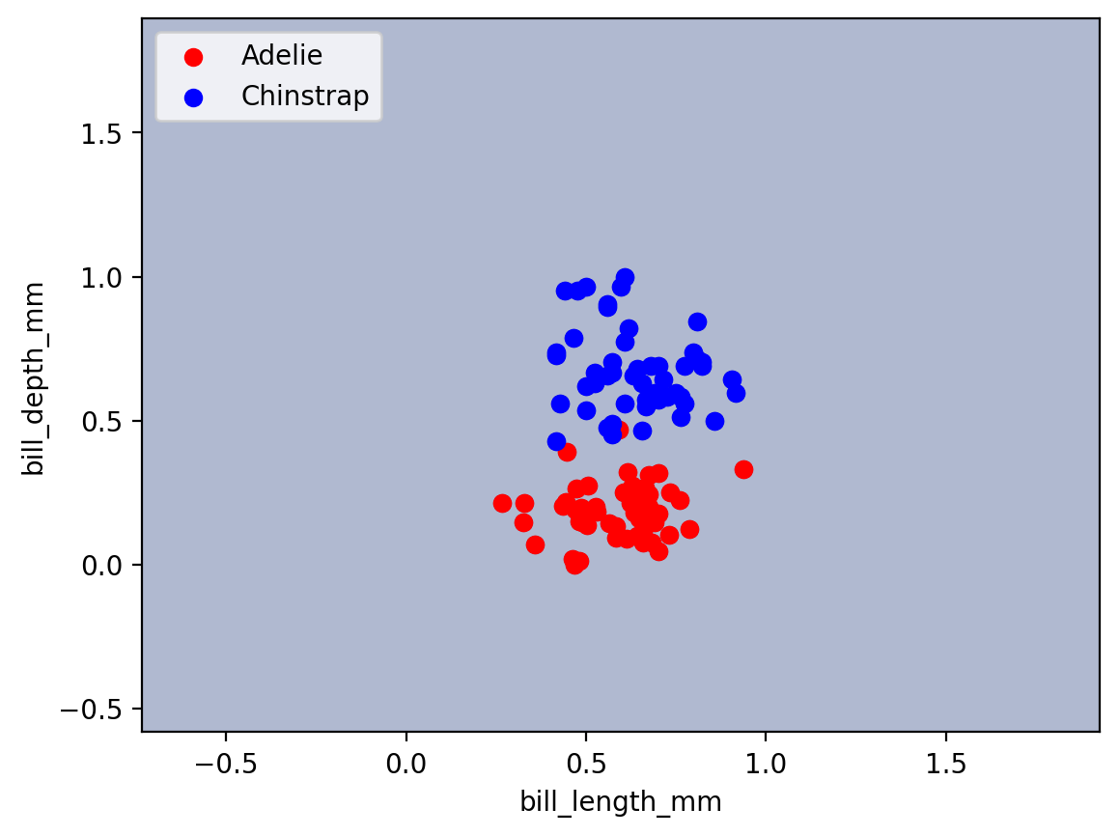

**Comment :** test accuracy = 0.5

bill_length_mm, flipper_length_mm

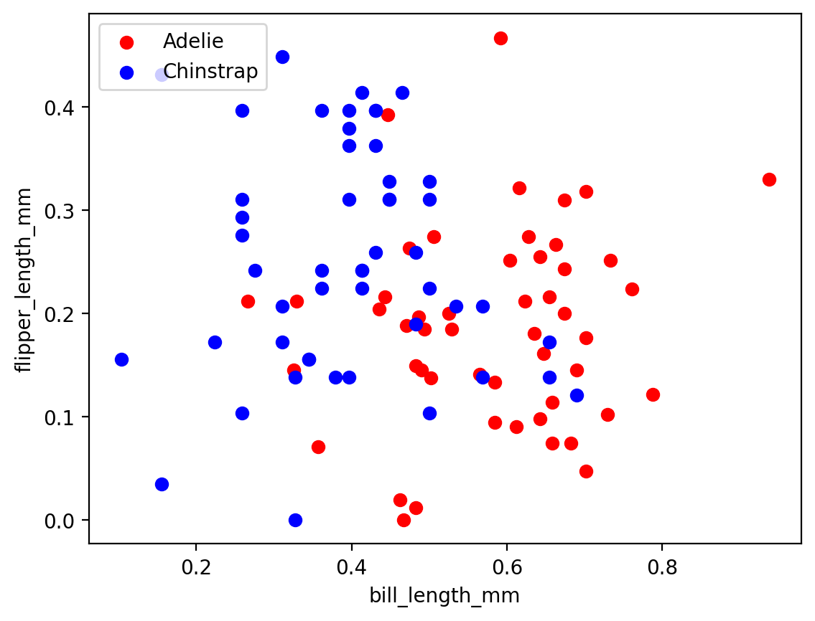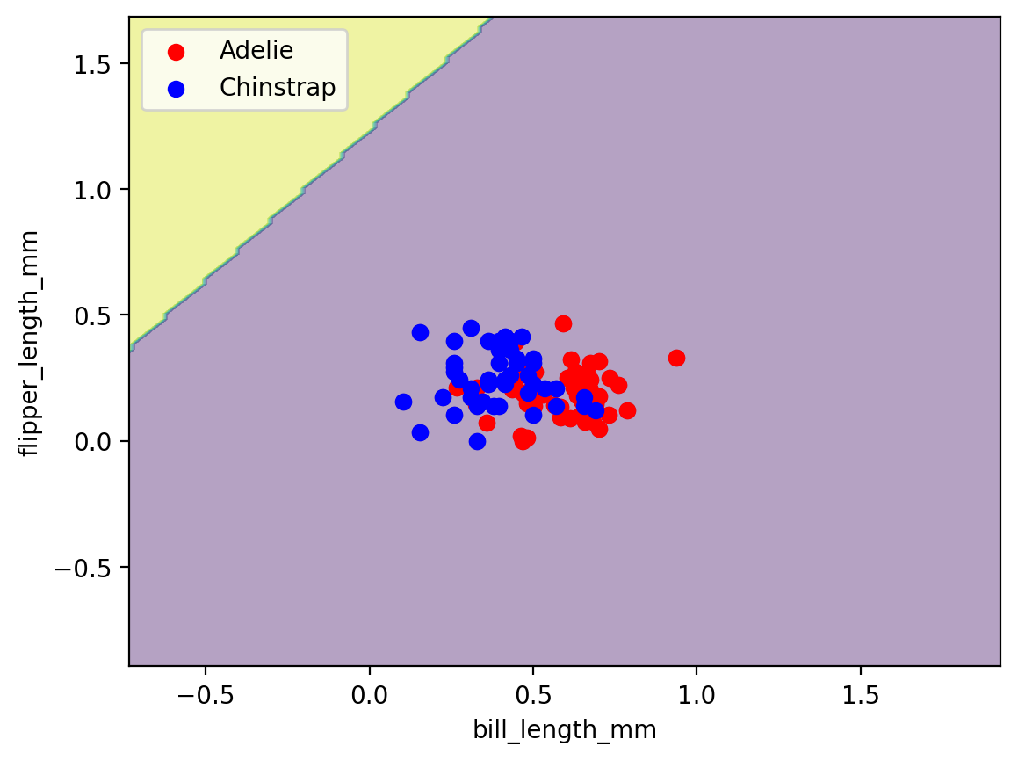

**Comment:** test accuracy = 0.5

### bill_length_mm , gender

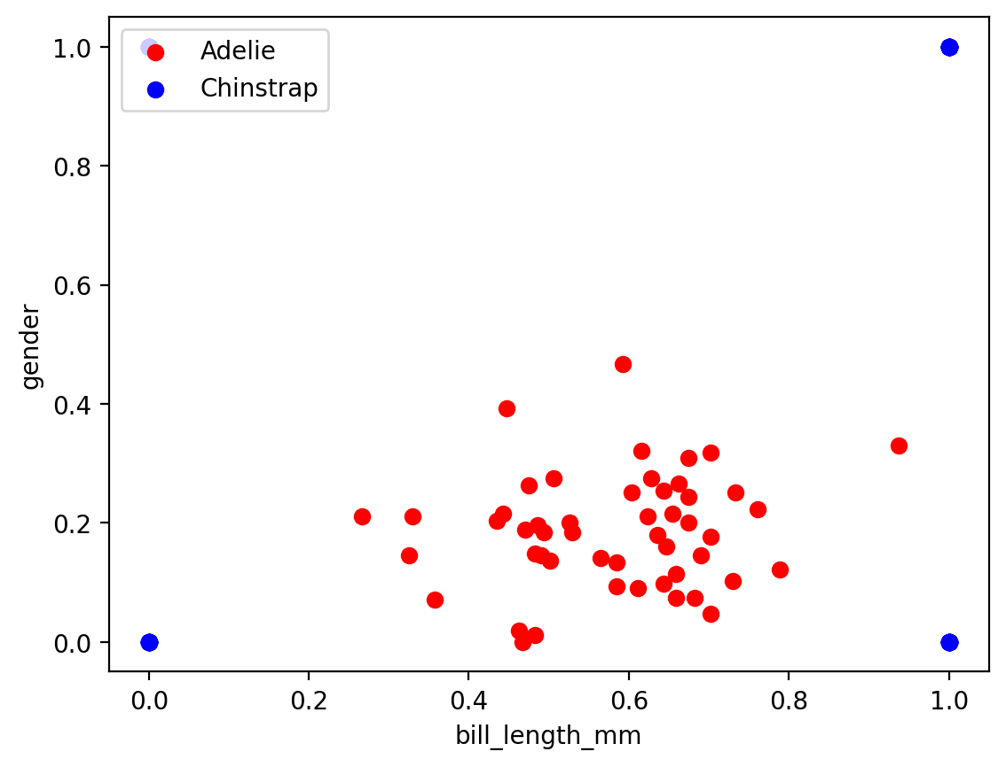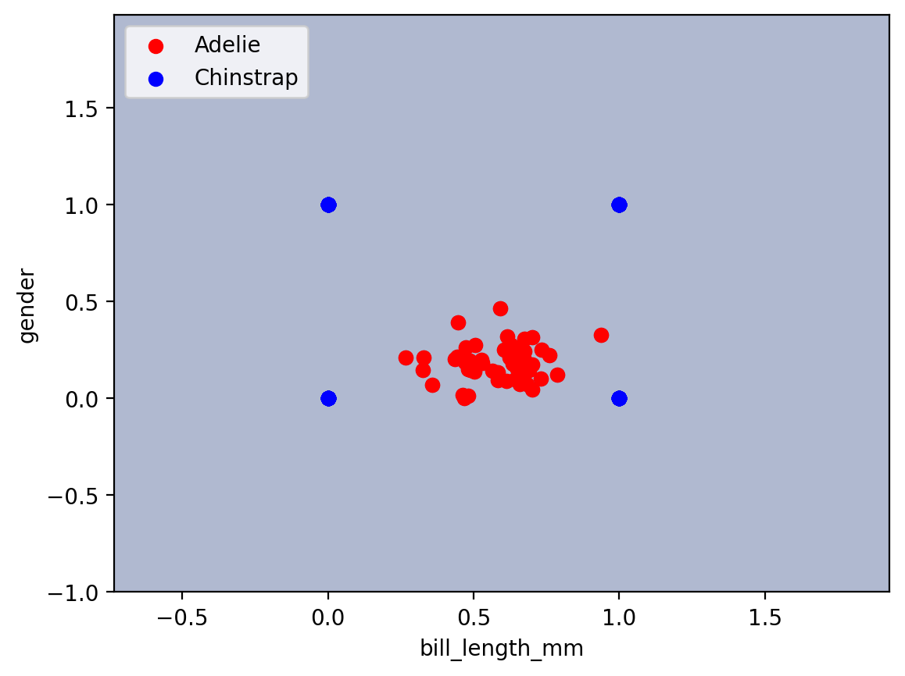



**Comment :** test accuracy = 0.5

bill_length_mm , body_mass_g

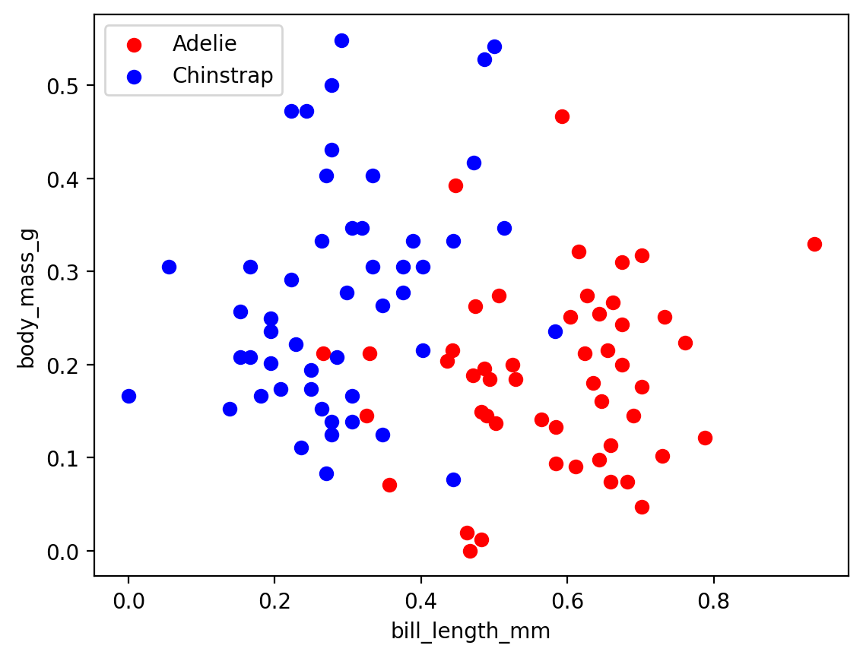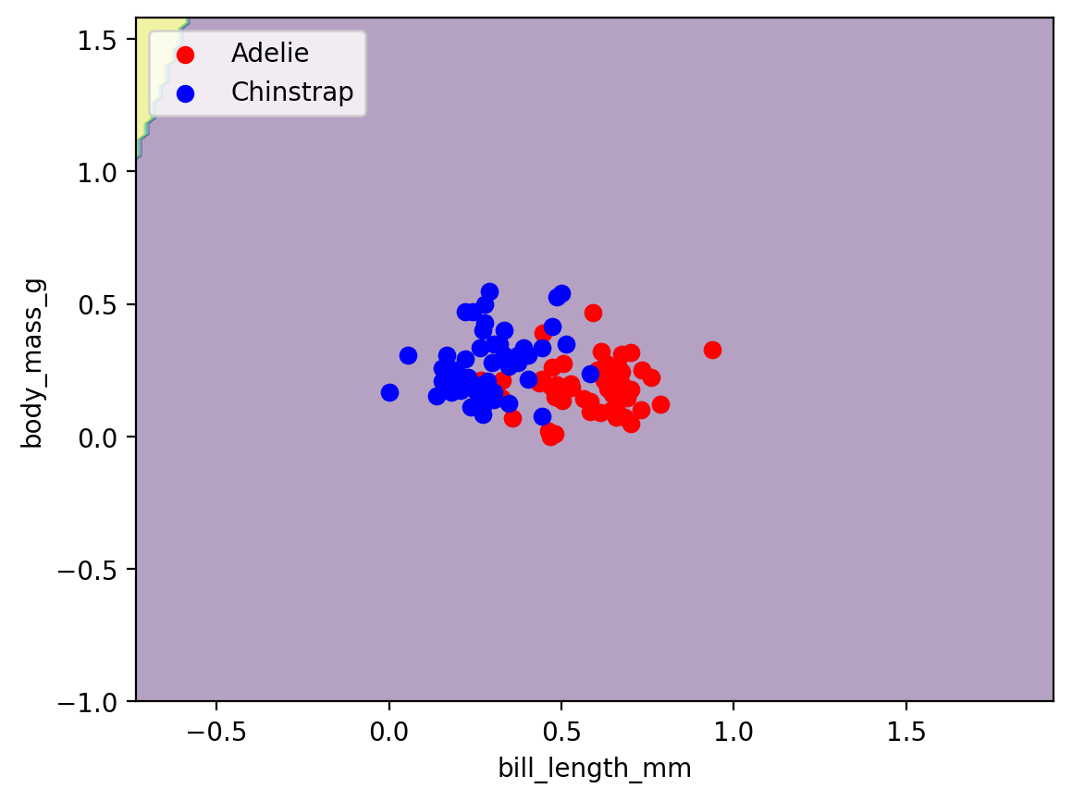



**Comment:** test accuracy = 0.5

bill_depth_mm , flipper_length_mm

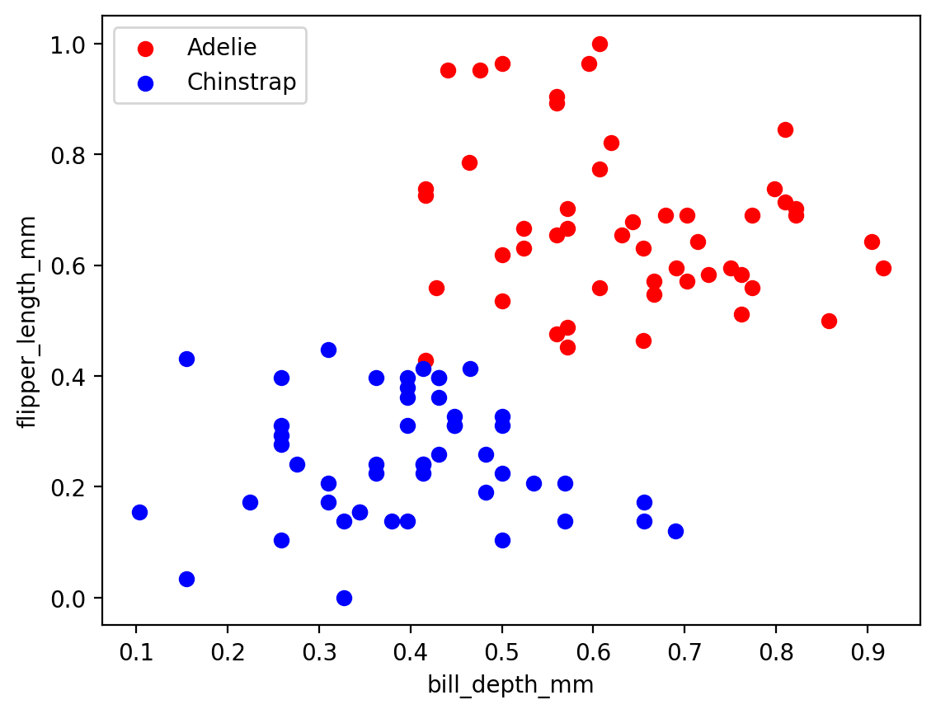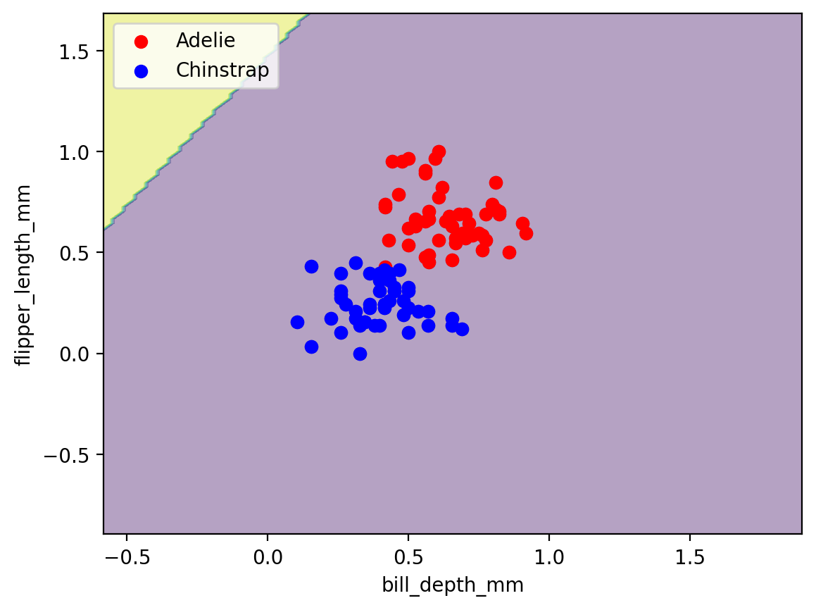



**Comment:** test accuracy = 0.5

bill_depth_mm , gender

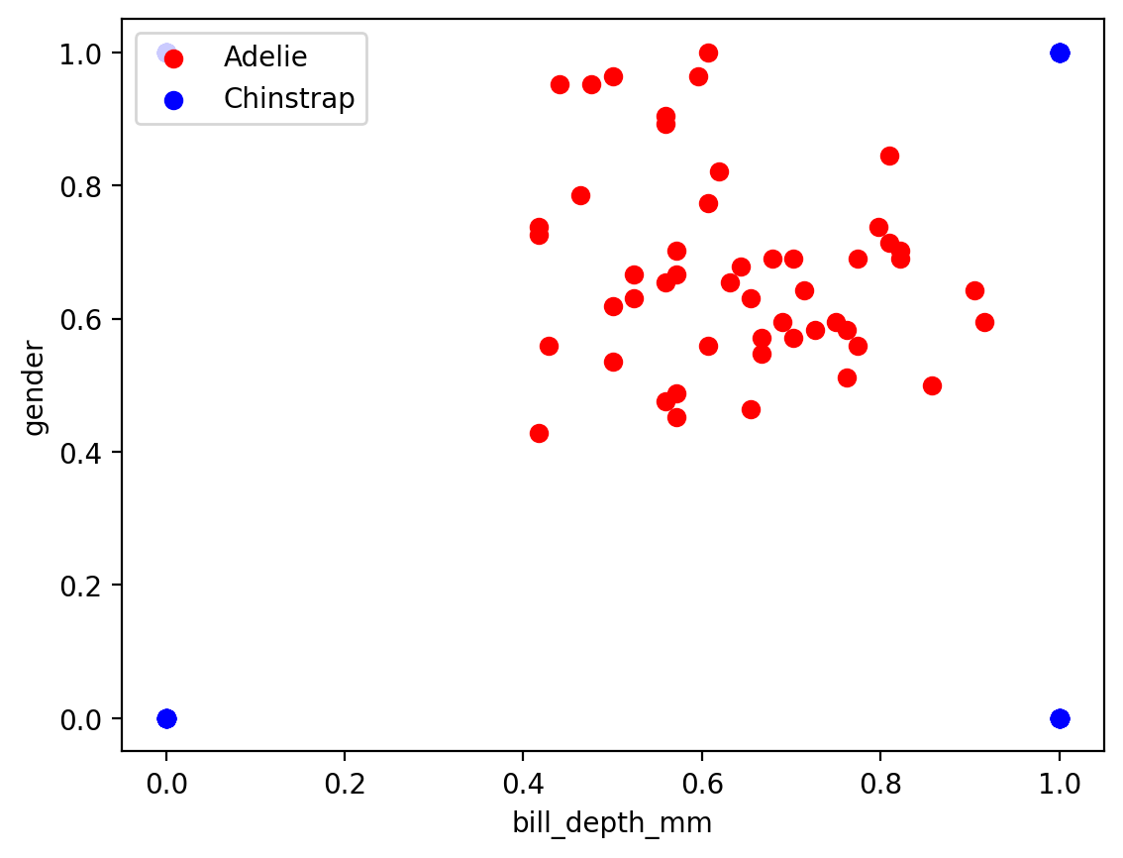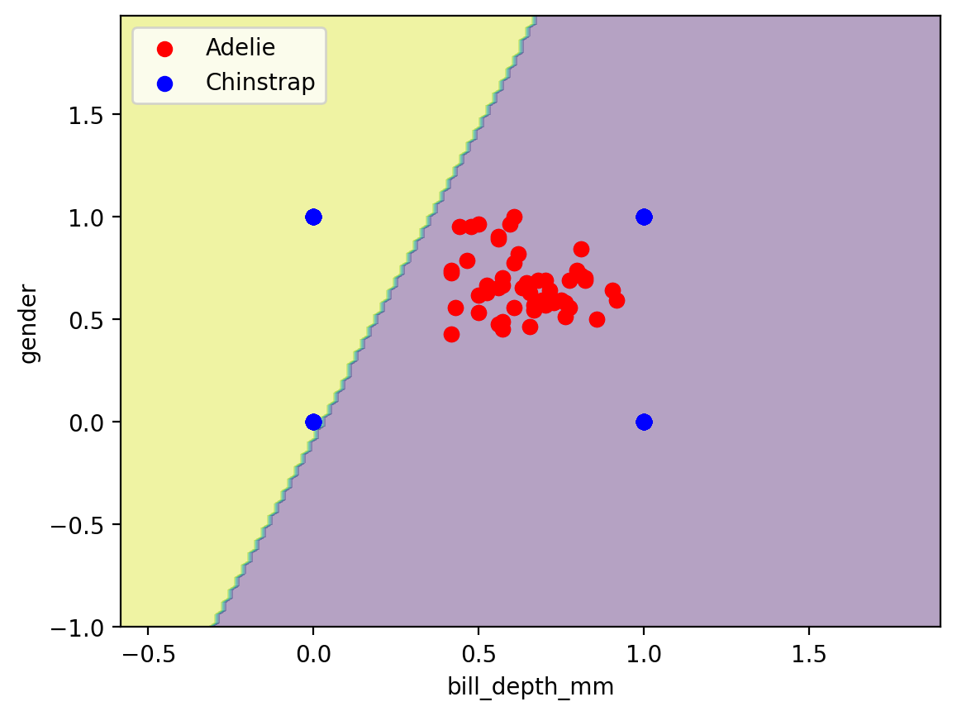

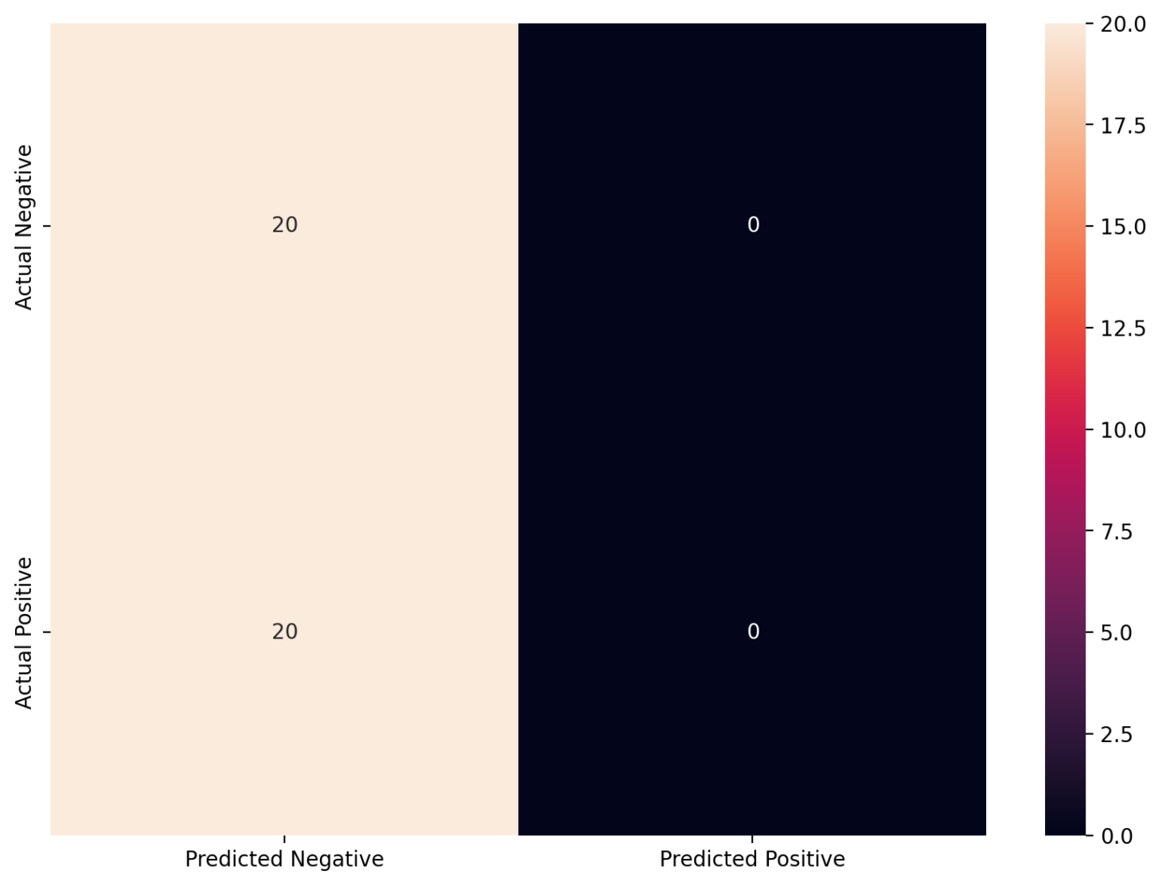

**Comment:** test accuracy = 0.5

### 

### bill_depth_mm , body_mass_g

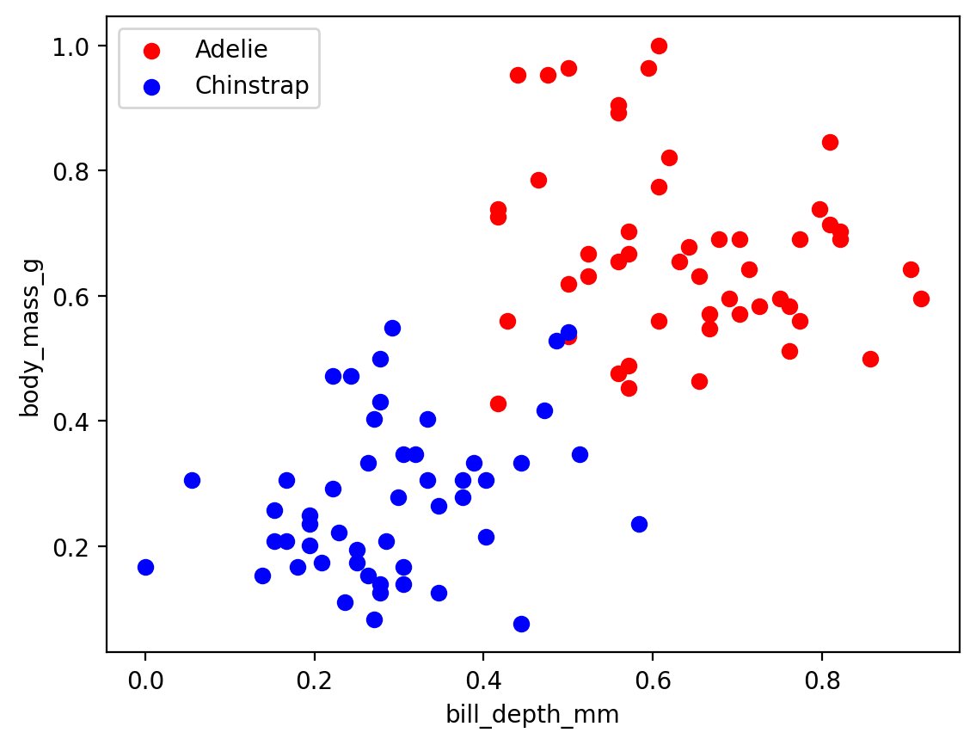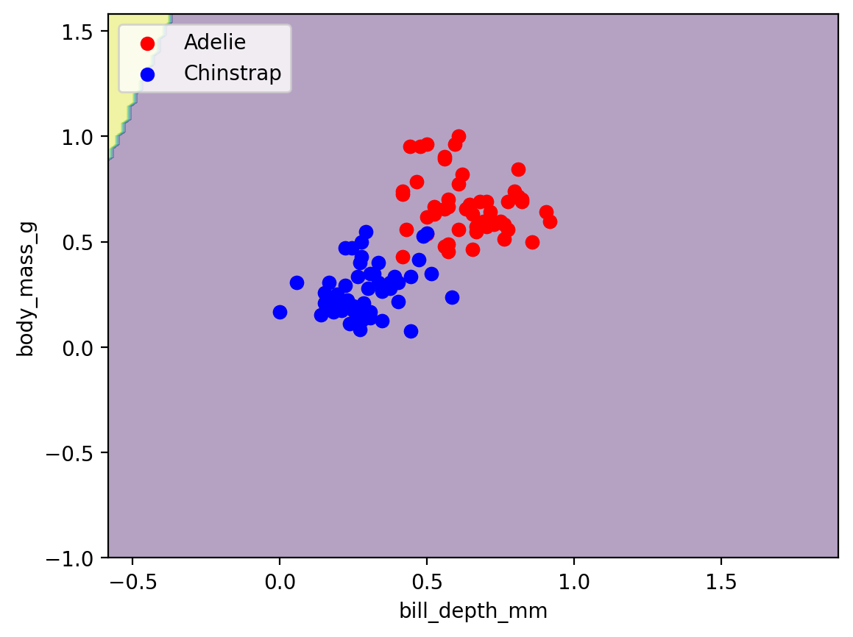



**Comment:** test accuracy = 0.5

### flipper_length_mm , gender

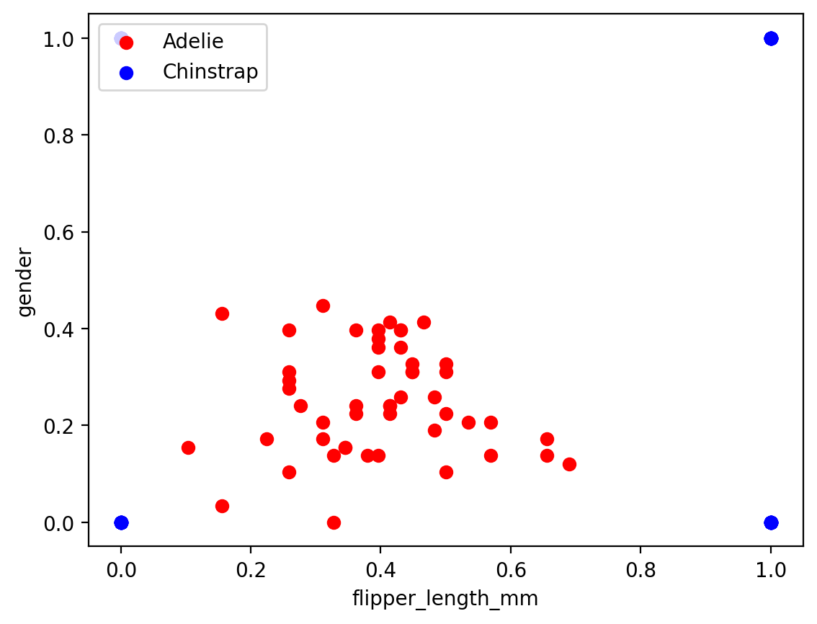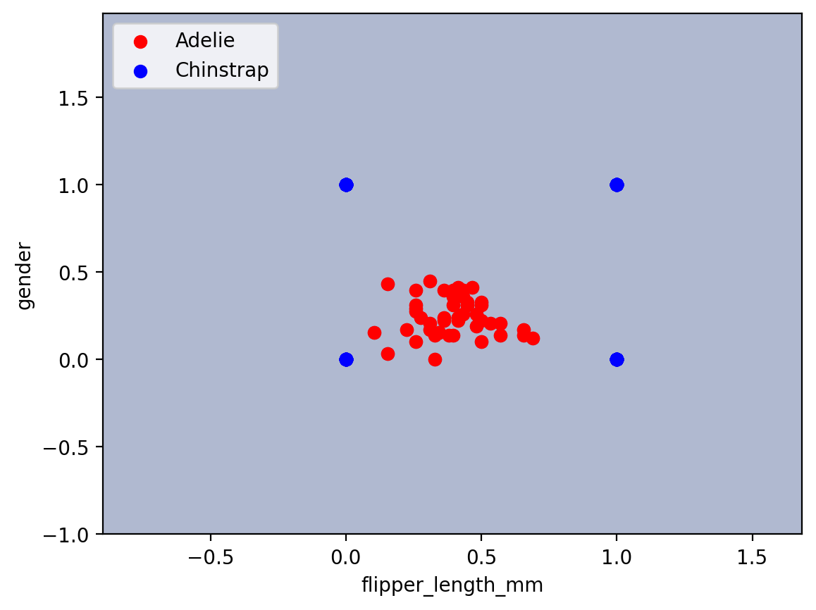



**Comment:**test accuracy = 0.5

### 

### flipper_length_mm , body_mass_g

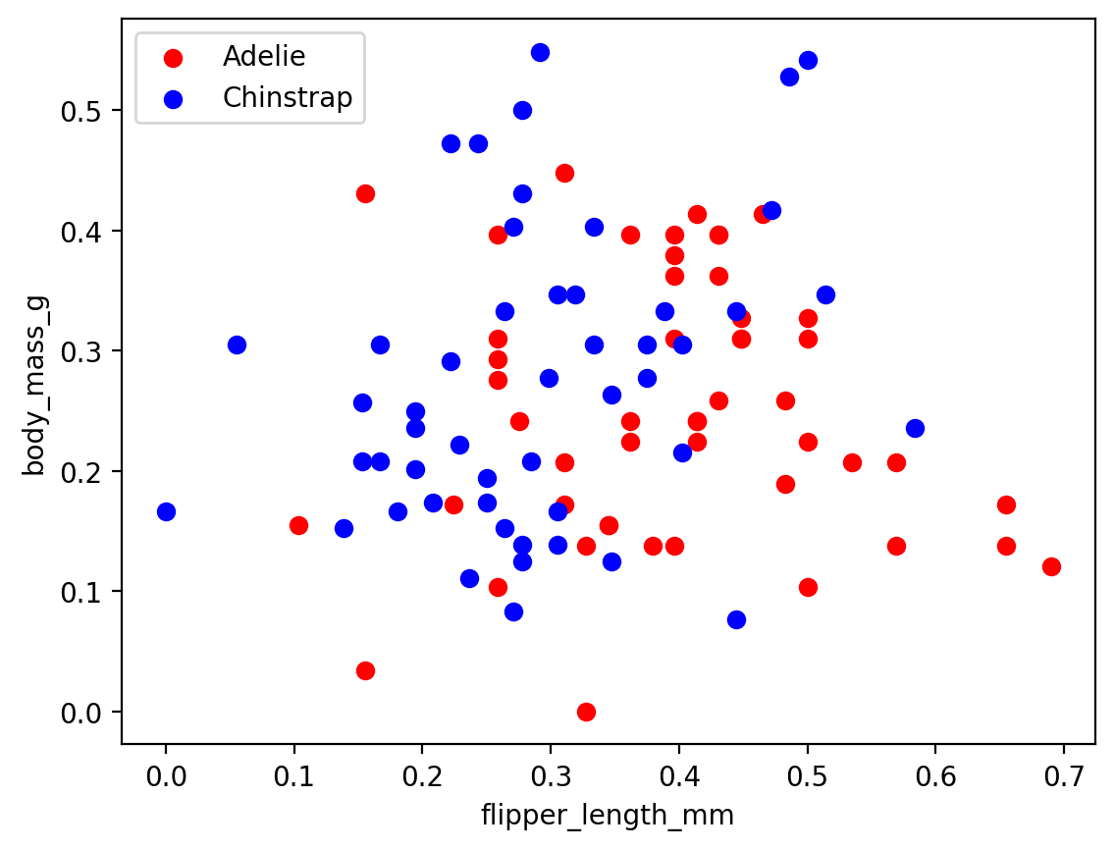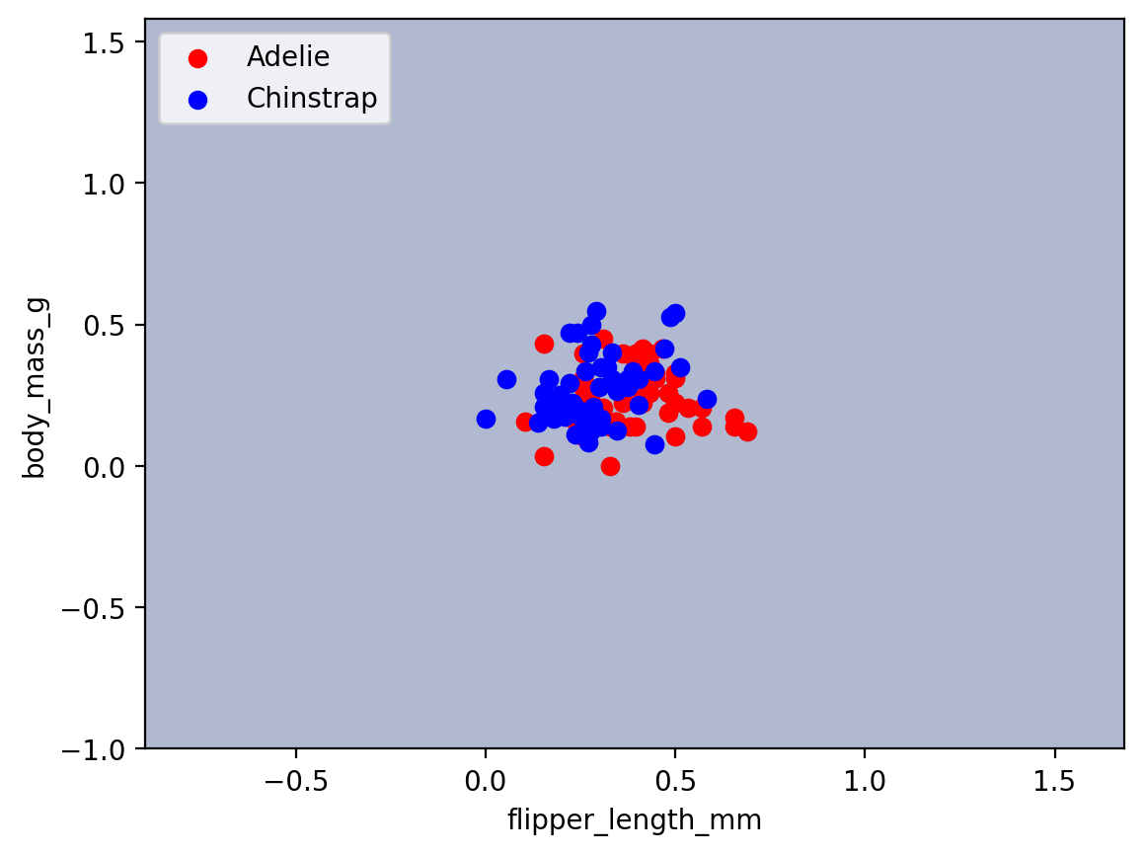



**Comment:** test accuracy = 0.5

### gender , body_mass_g

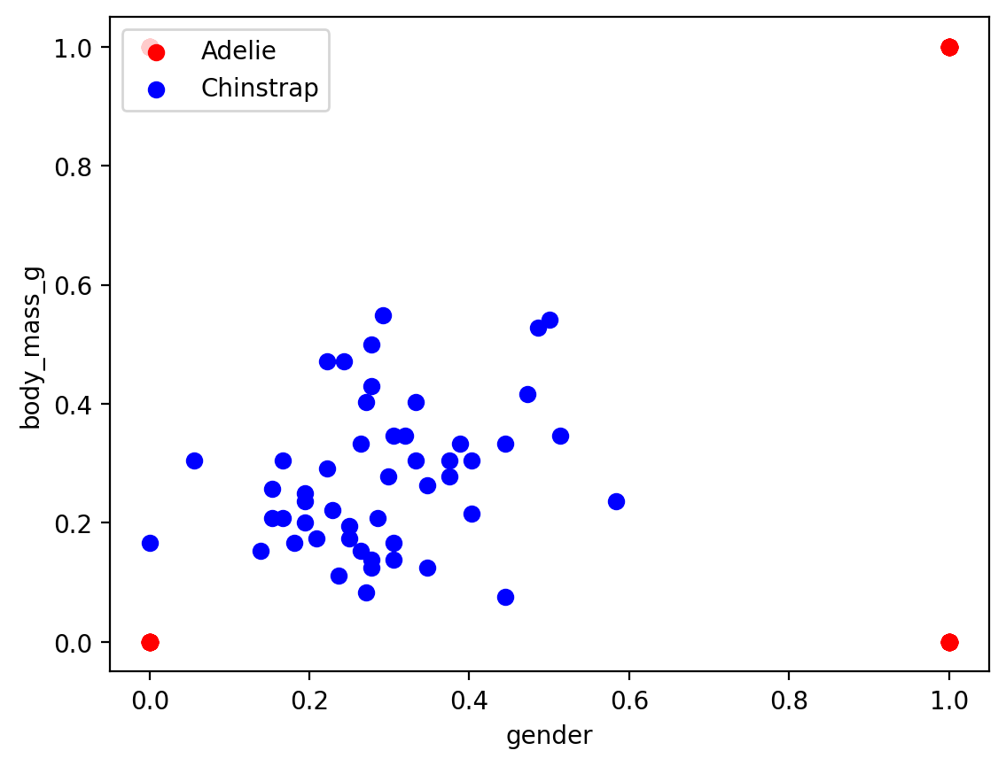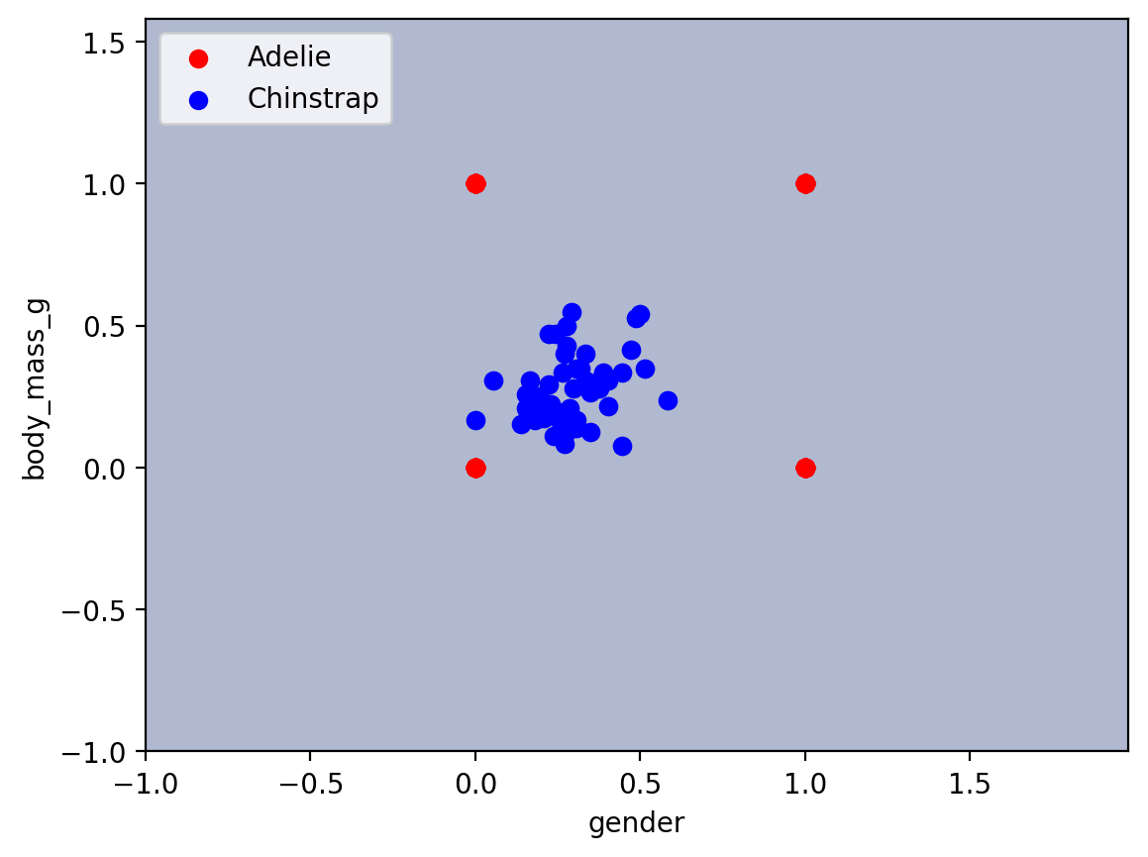



**Comment:** test accuracy = 0.5

# Chinstrap and Gentoo

### bill_length_mm , bill_depth_mm

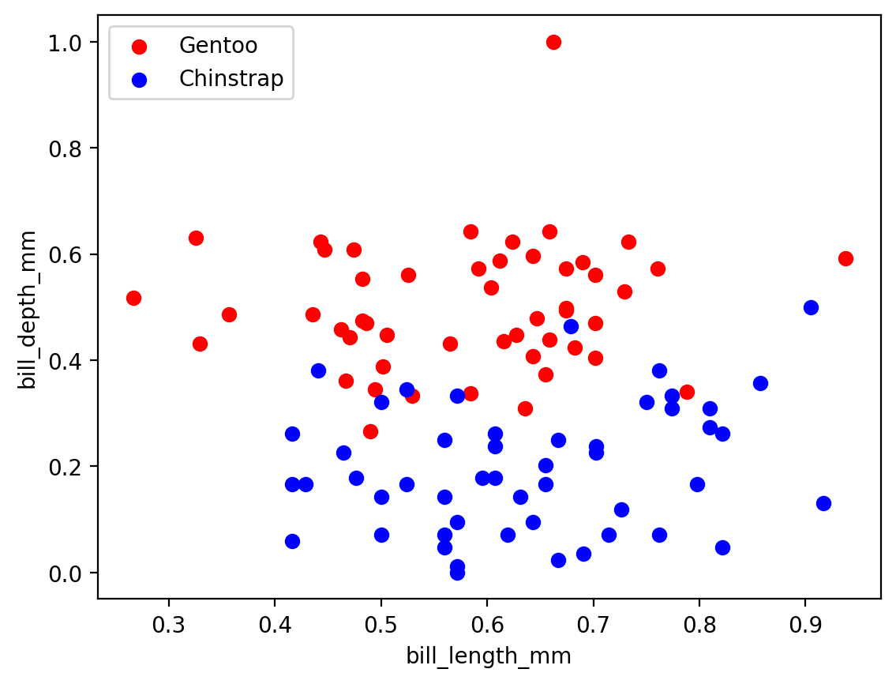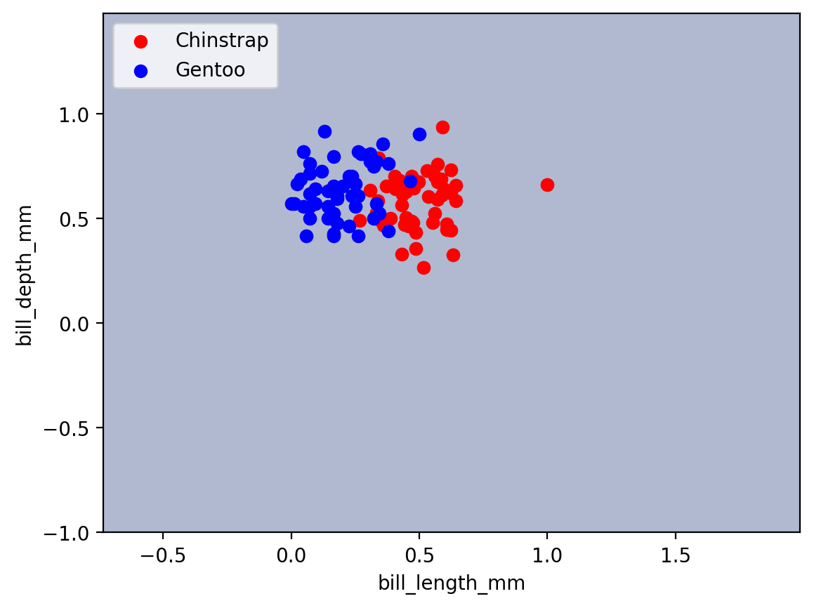

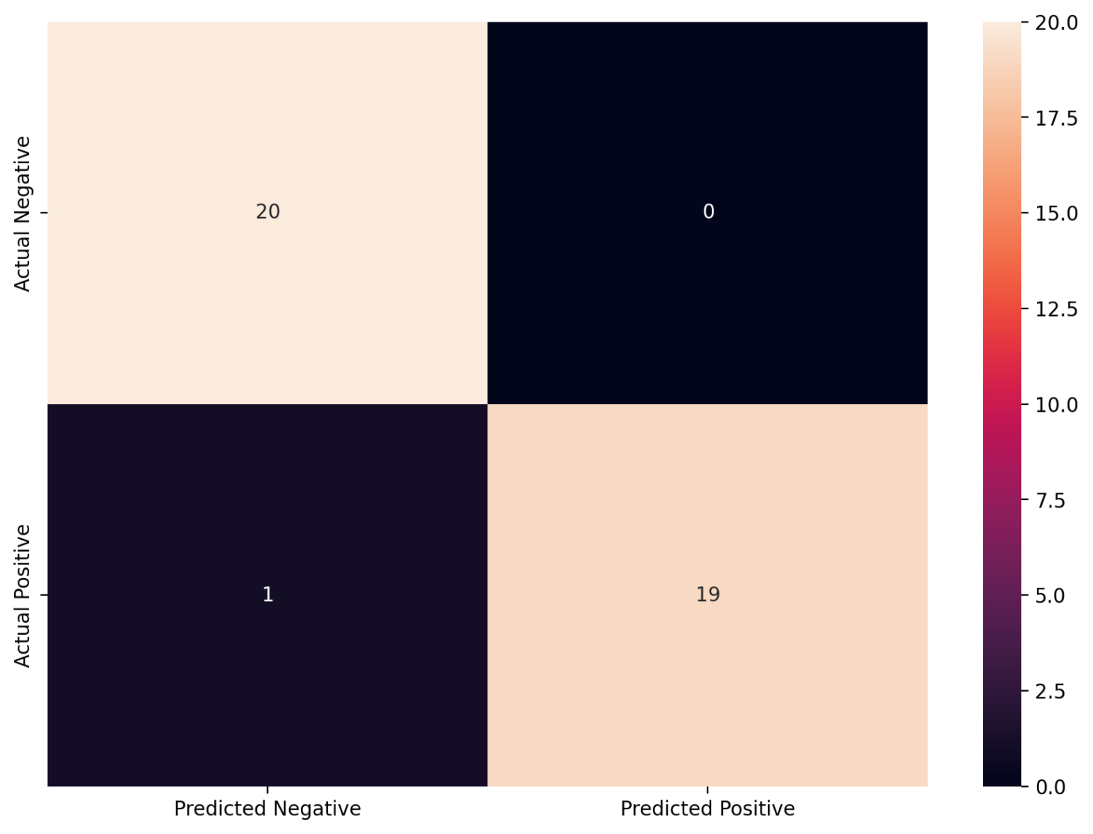

**Comment:** test accuracy = 0.5

### bill_length_mm, flipper_length_mm

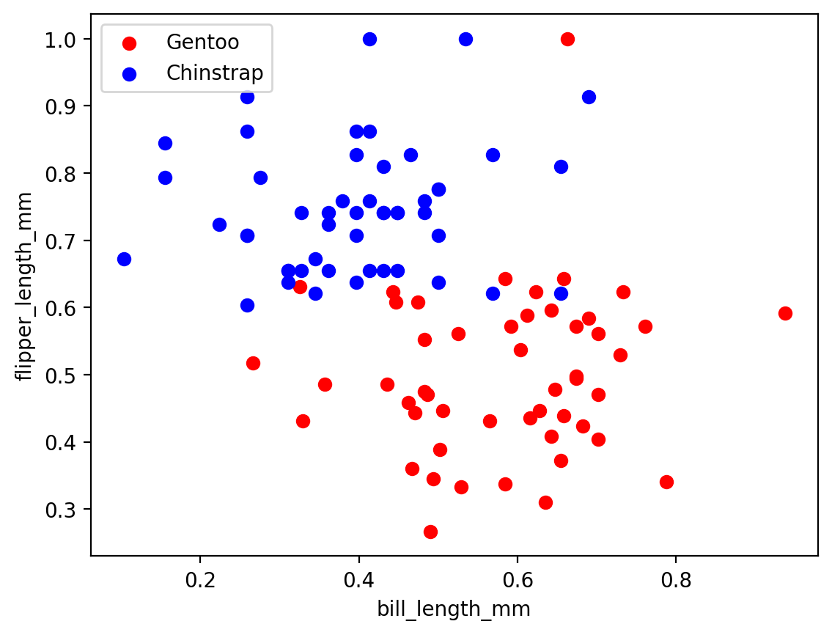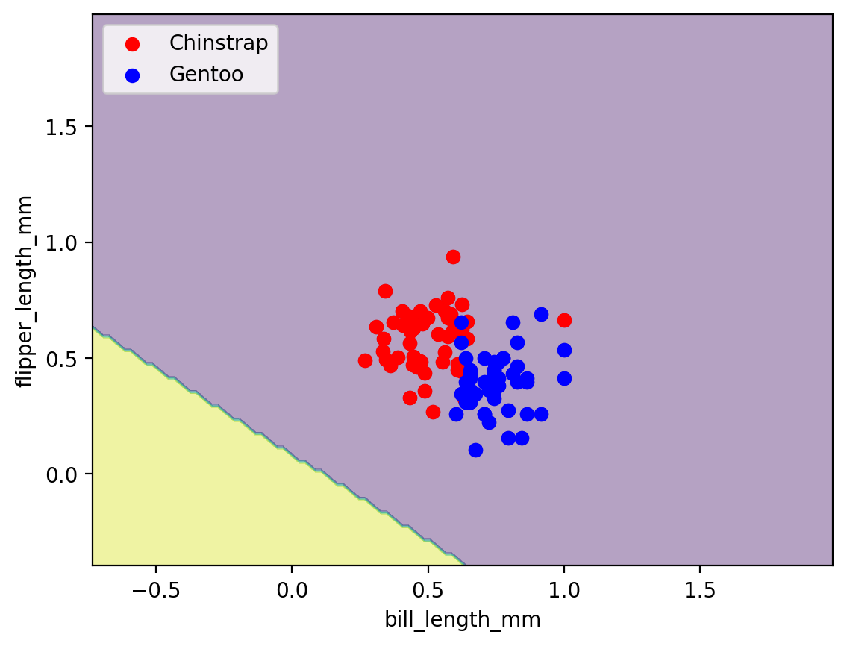



**Comment:** test accuracy = 0.5

### bill_length_mm , gender

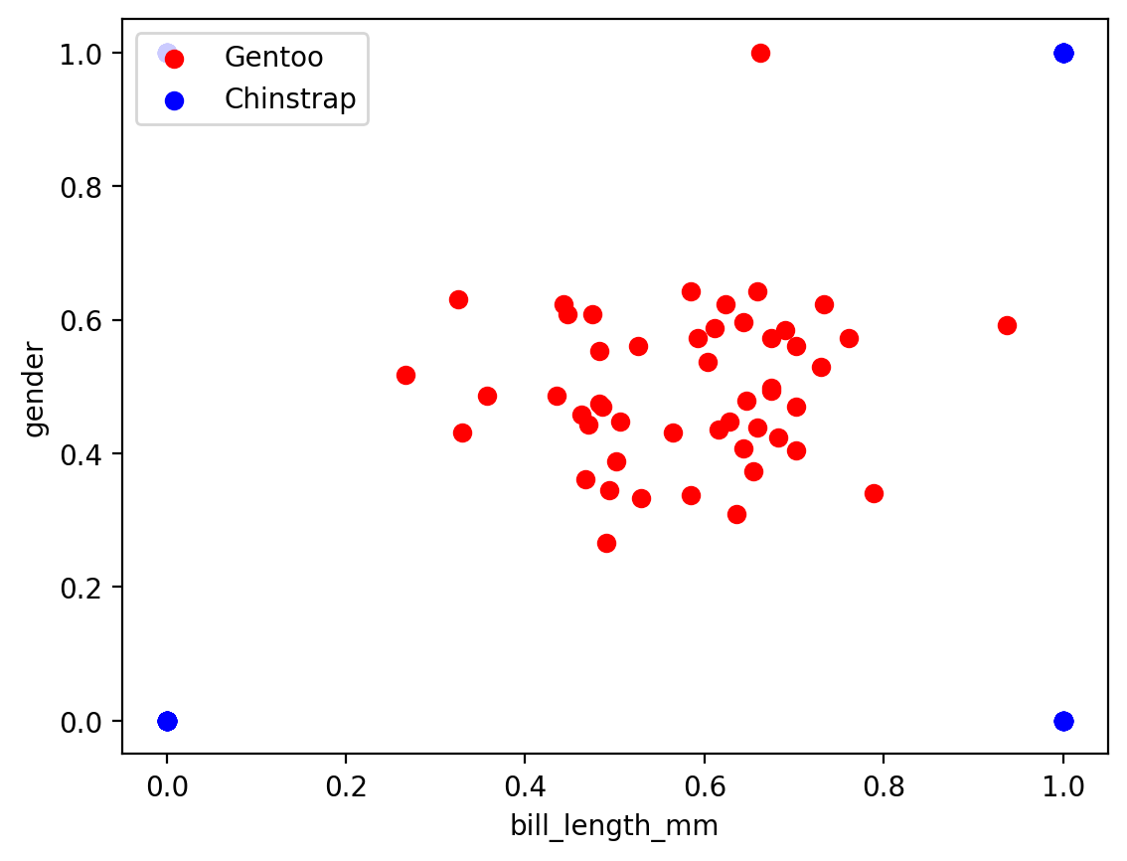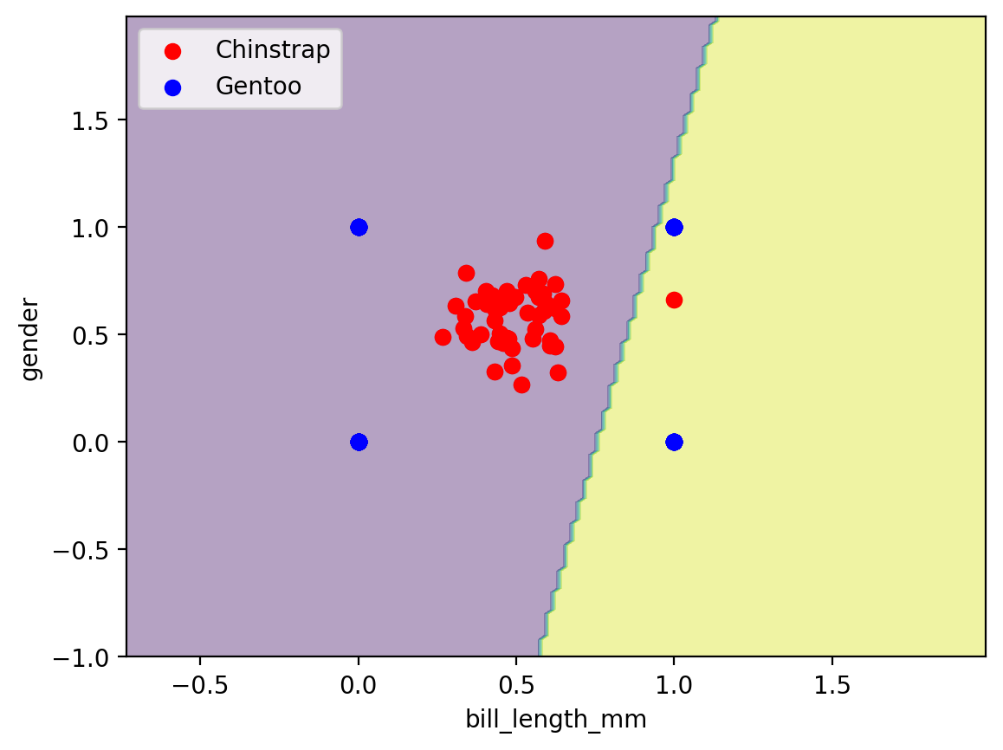  
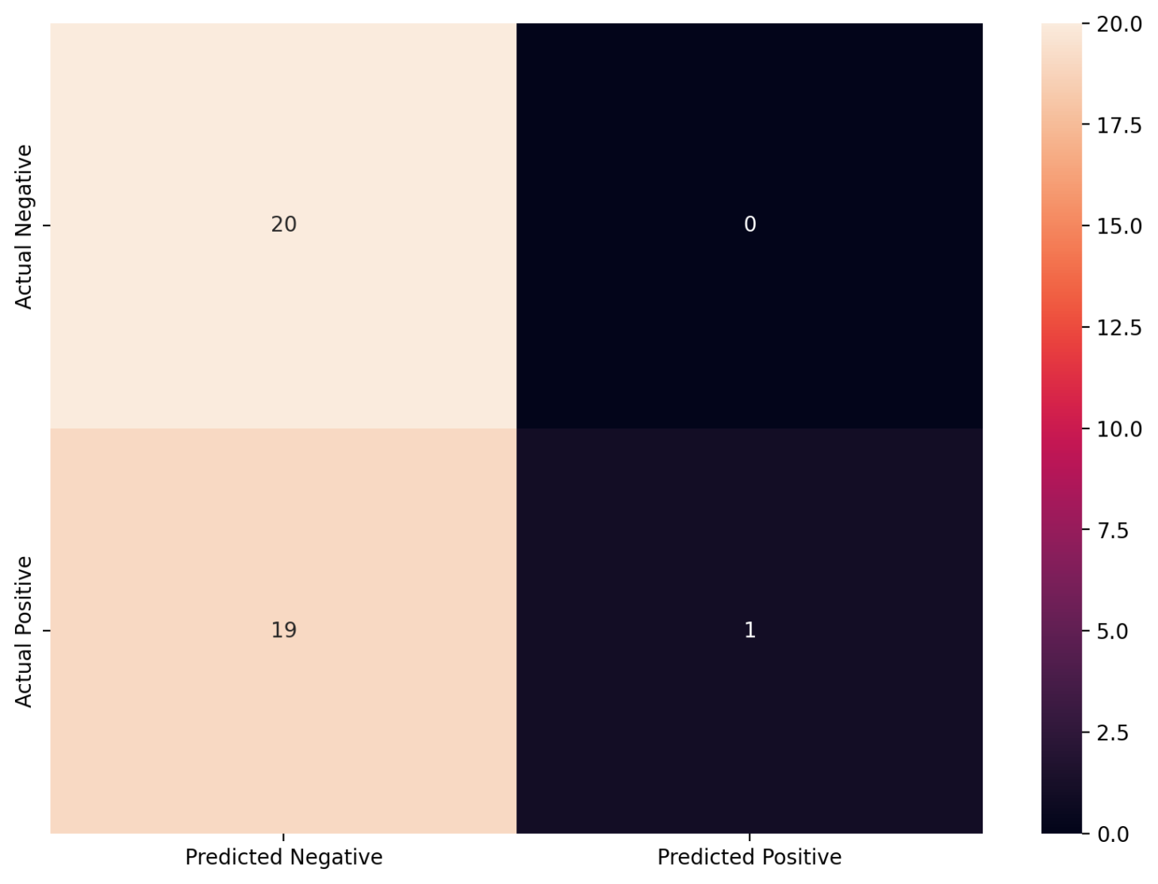

**Comment:** test accuracy = 0.525

### bill_length_mm , body_mass_g

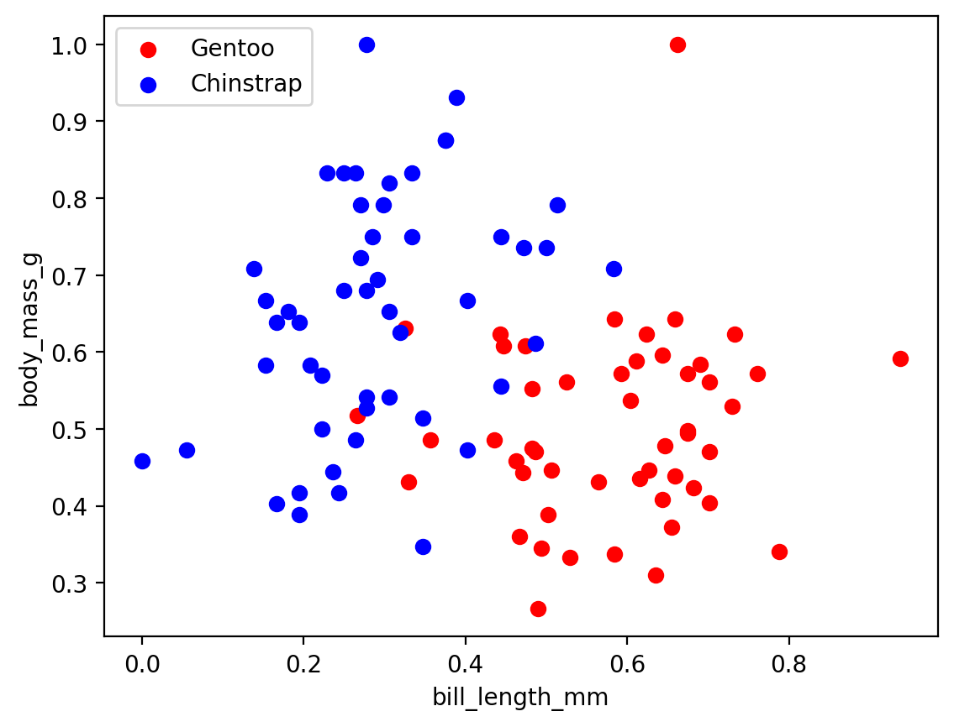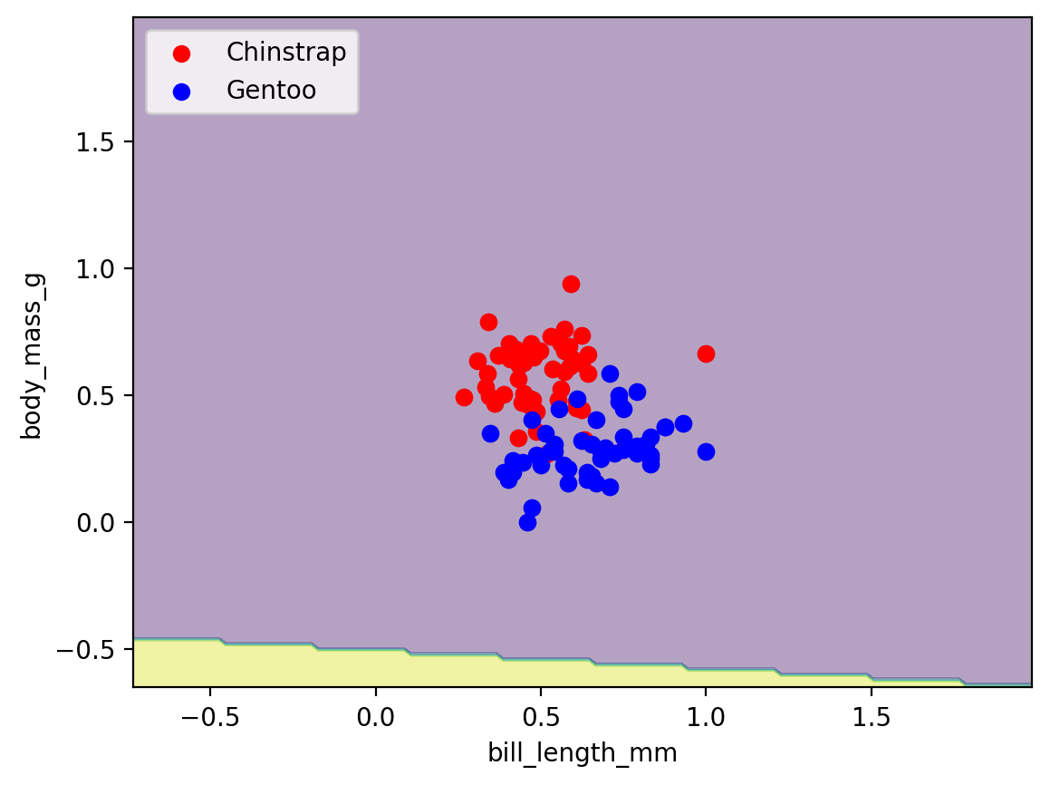



**Comment:** test accuracy = 0.5

### bill_depth_mm , flipper_length_mm

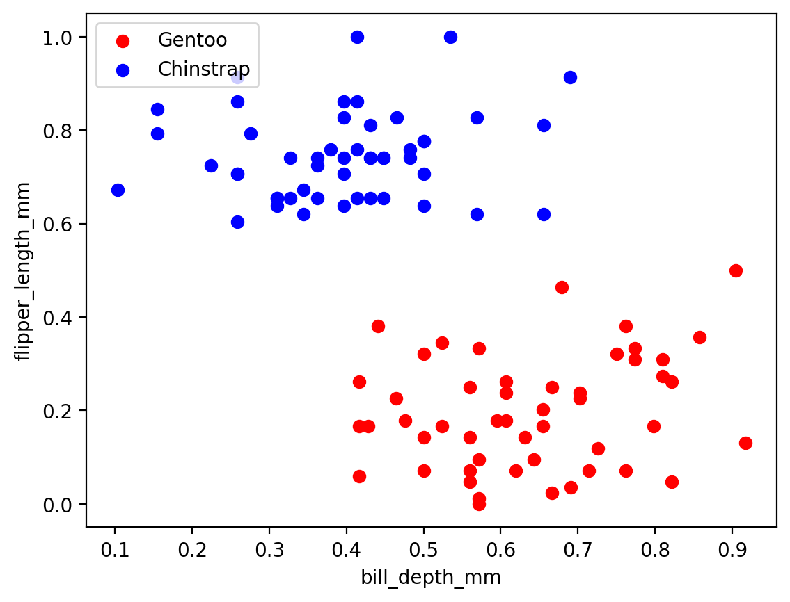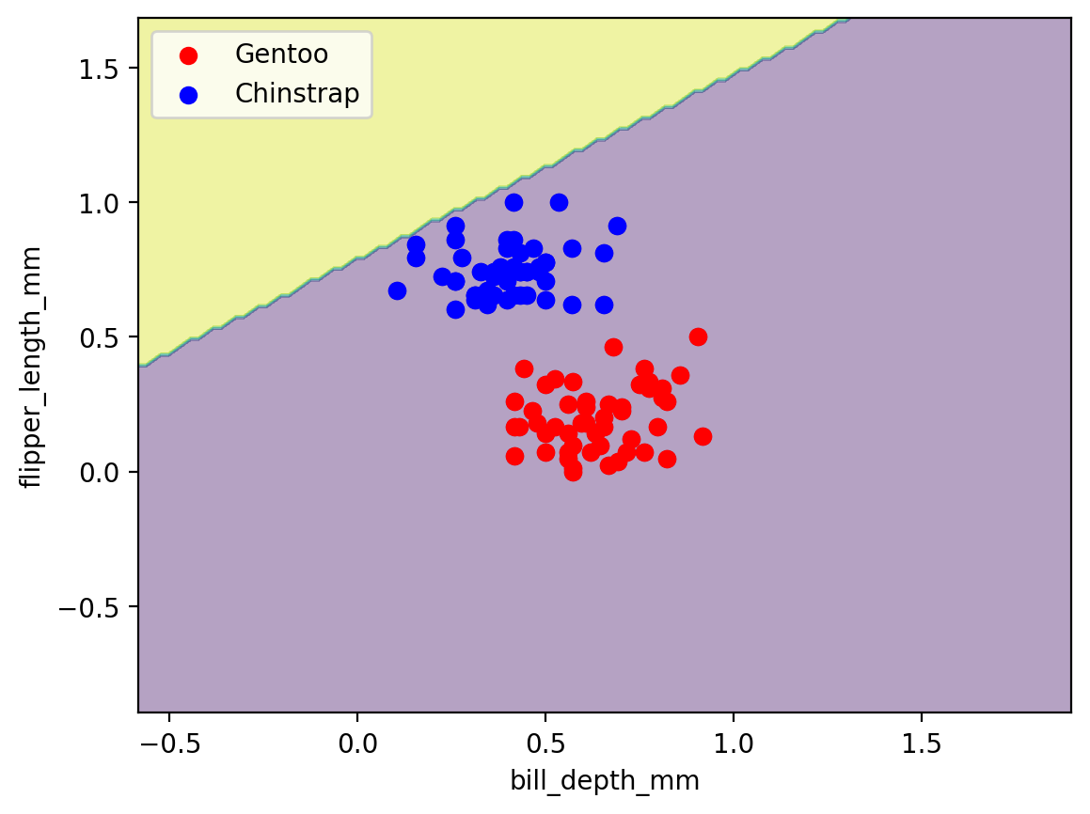



**Comment:** test accuracy = 0.5

bill_depth_mm , gender

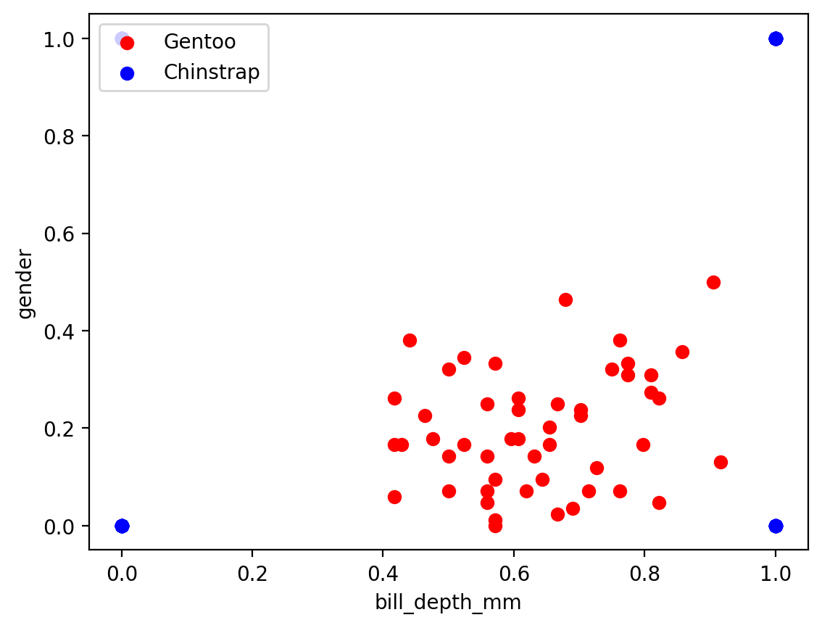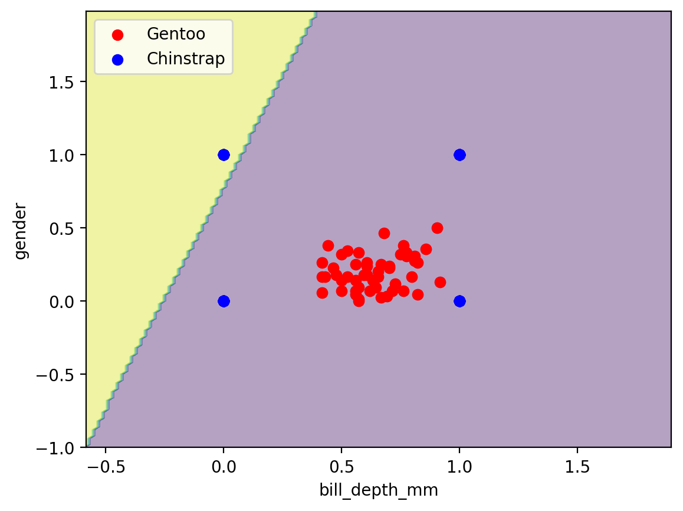



**Comment:** test accuracy = 0.5

bill_depth_mm , body_mass_g

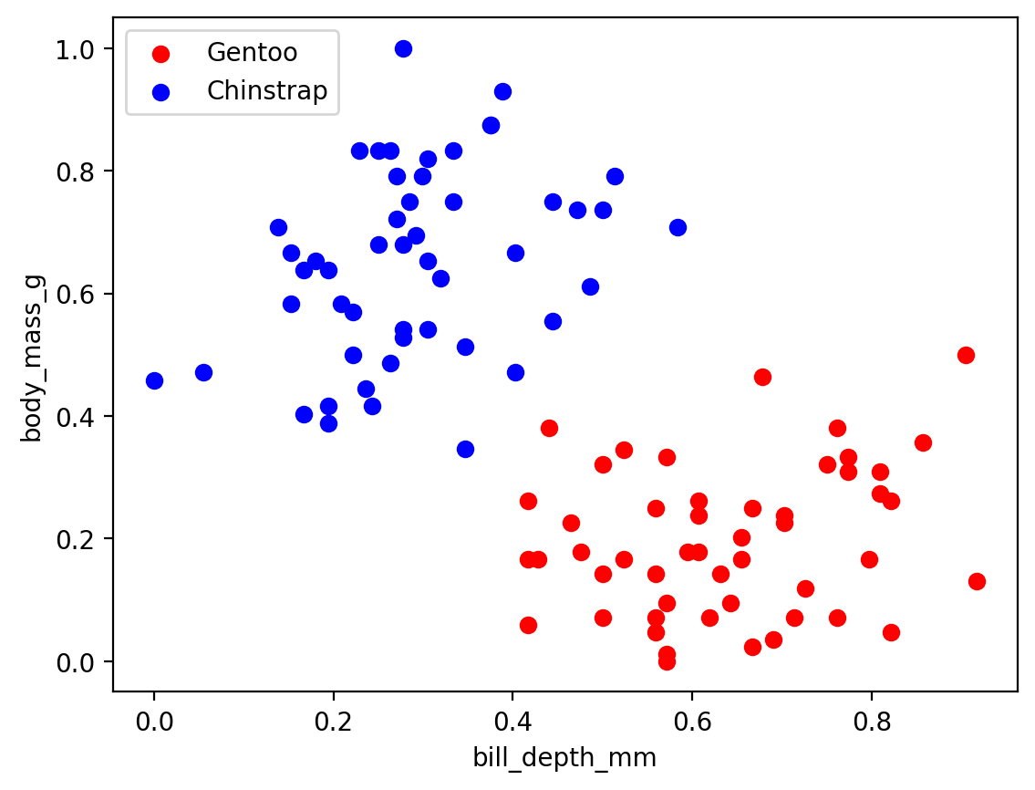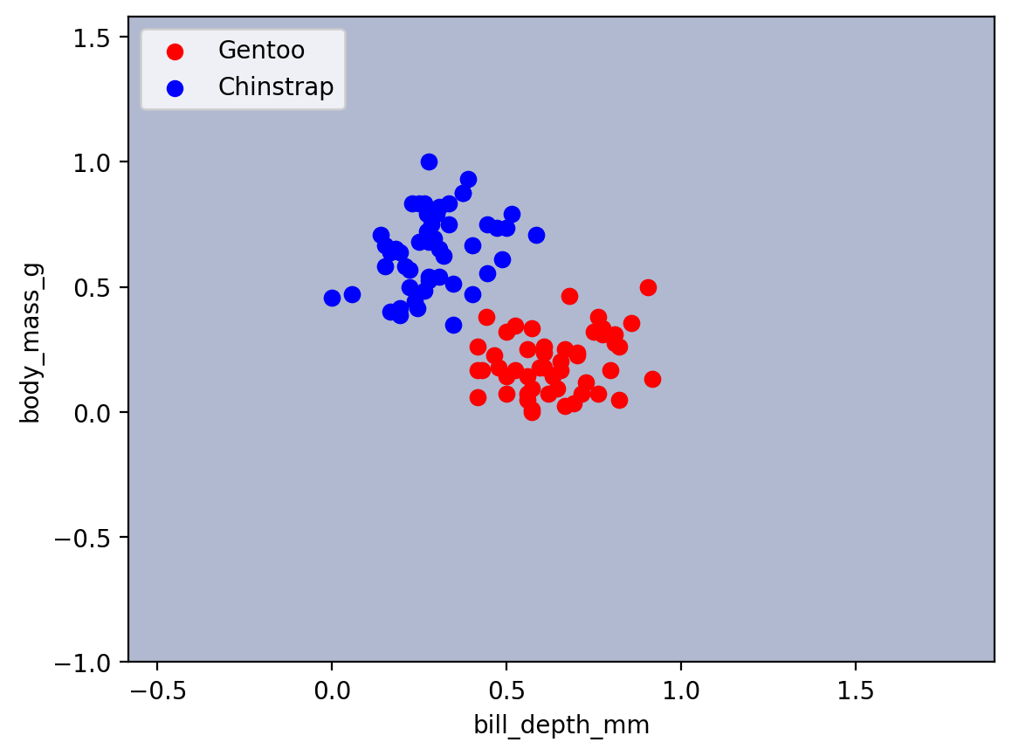



**Comment:** test accuracy = 0.5

### flipper_length_mm , gender

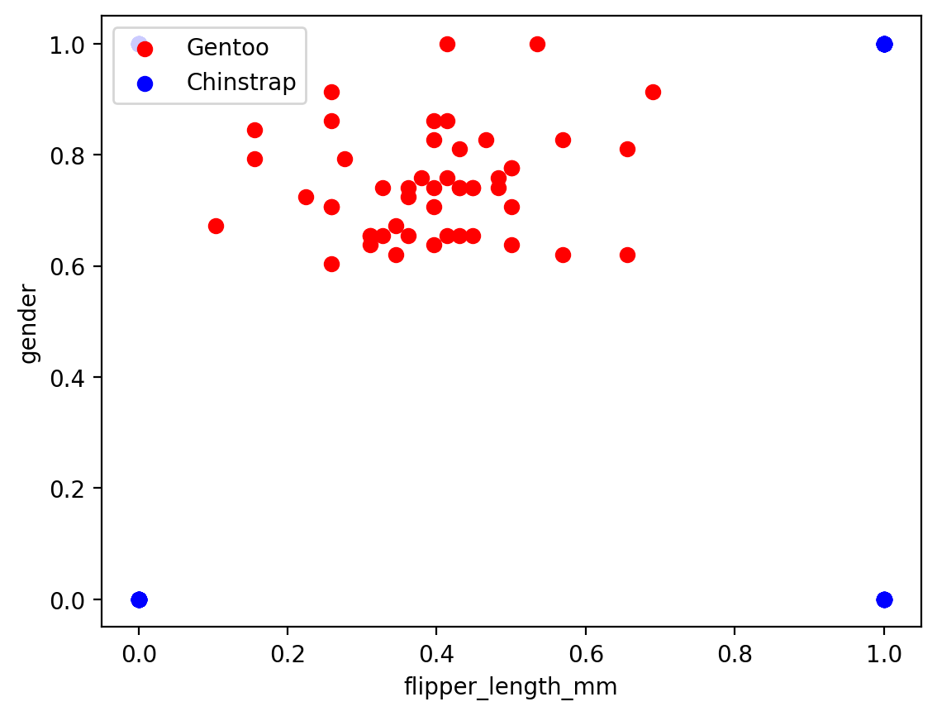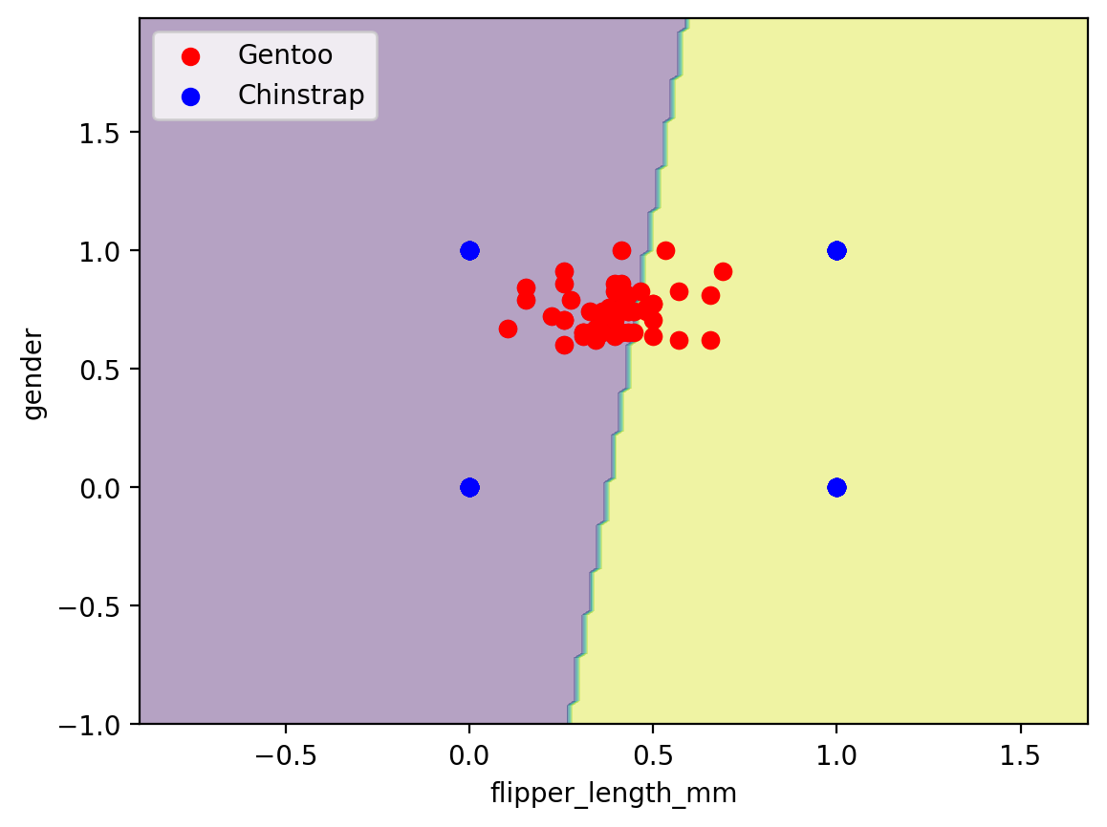

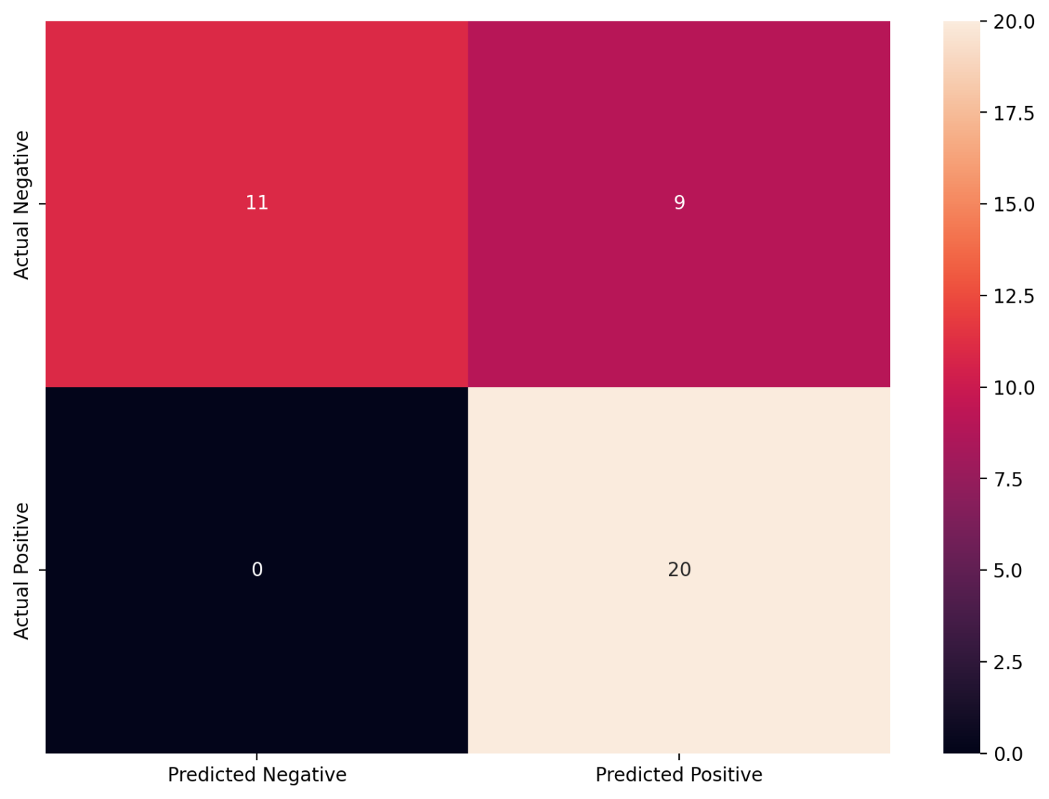

**Comment:**test accuracy = 0.775

### flipper_length_mm , body_mass_g

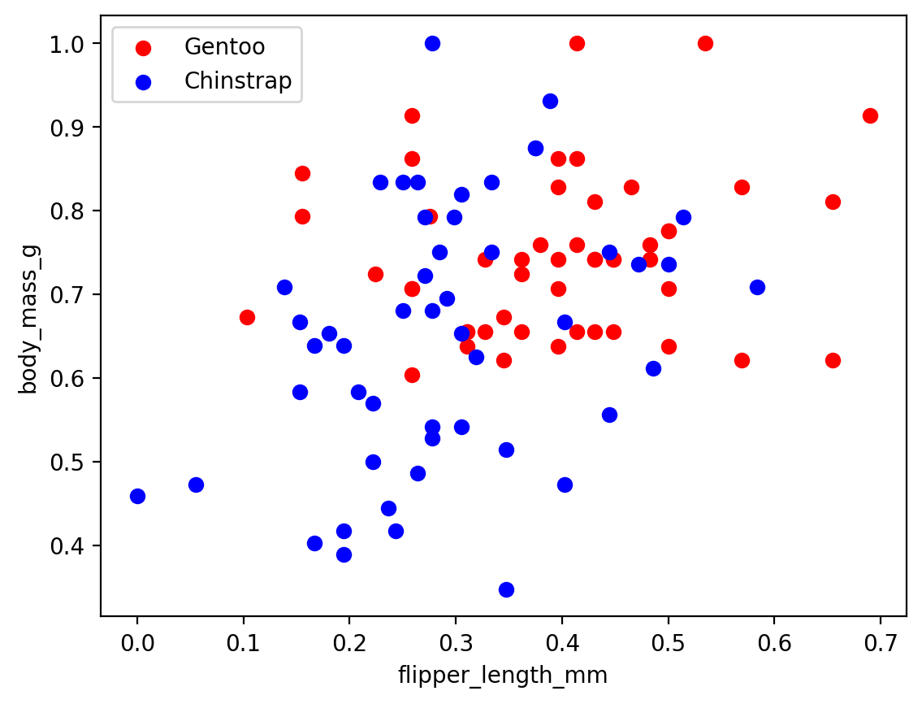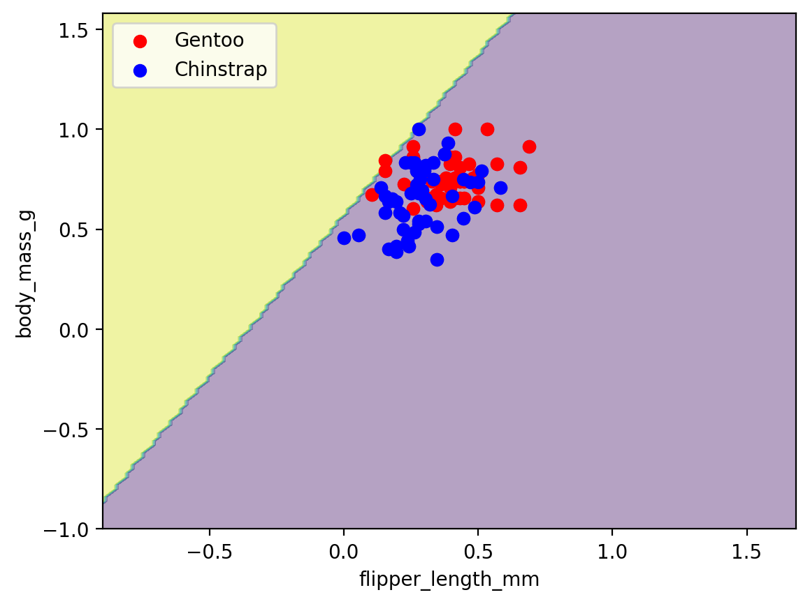



**Comment:**  test accuracy = 0.5

gender , body_mass_g

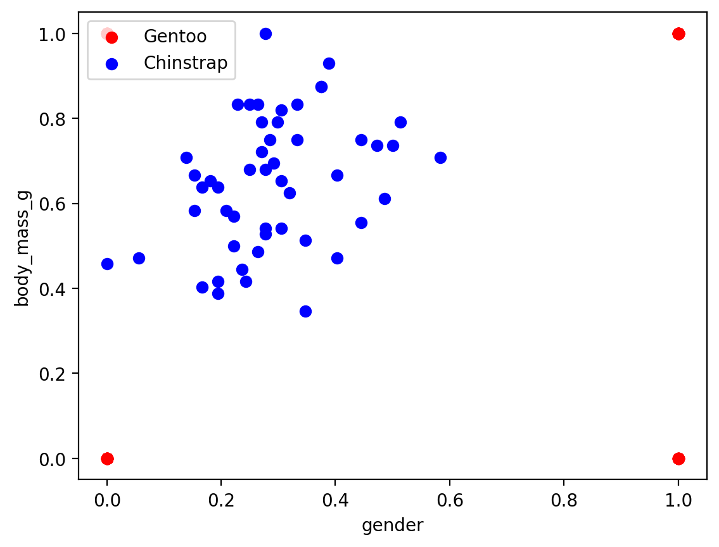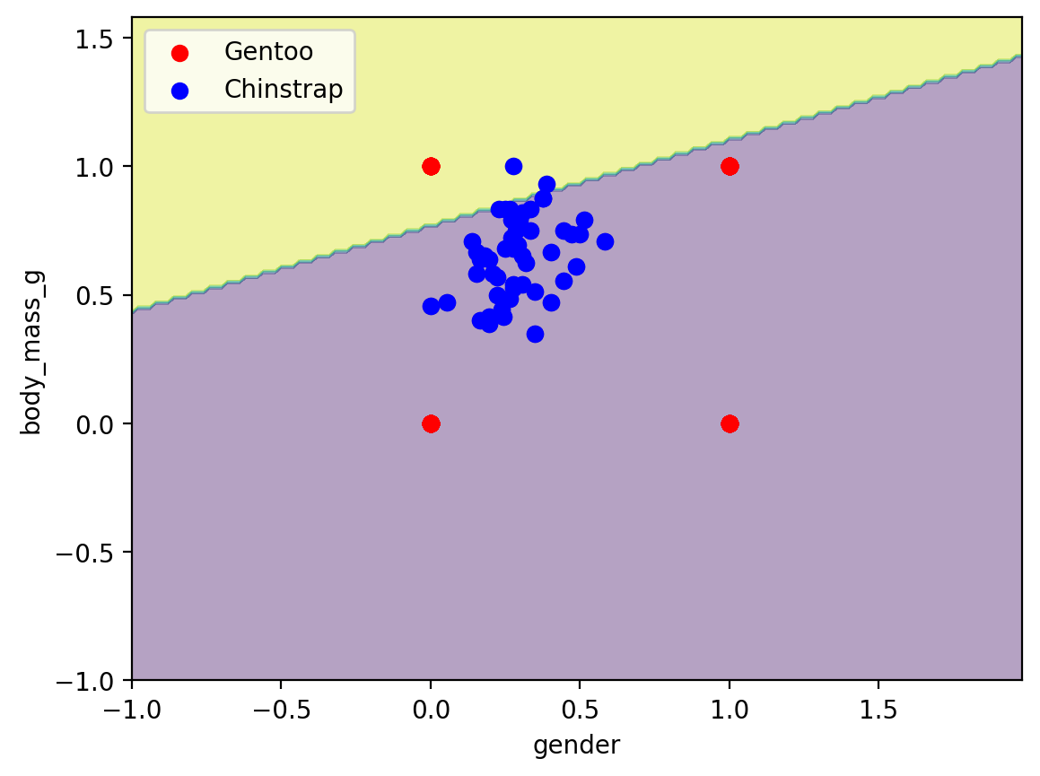



**Comment:** test accuracy = 0.5

# Overall comment:

* **the best features to classify between Adelie and Gentoo**
  + bill_length_mm , gender with test accuracy = 92.5%
* **The best Features to classify between Adelie and Chinstrap** 
  + No features are good enough to classify between them
* **The best Features to classify between Chinstrap and Gentoo**
  + flipper_length_mm , gender with test accuracy = 77.5%

# Note:

inorder to run the model

* streamlit have to be installed using pip install streamlit
* then run the model using streamlit run GUI.py from terminal